**CHAPTER ONE: NATURAL RESOURCES**

Natural resources are things obtained from the physical environments meet need of the living organisms.

The examples of the natural resources include the following

1. Water
2. Air/wind
3. Vegetation
4. Soil
5. Sunlight
6. Mineral
7. Sunlight Wildlife

**IMPORTANCE OF WATER IN AGRICULTURAL PRODUCTION**

1. It assists in germination of seeds.
2. It assists in dissolution and uptake of plant nutrients or elements.
3. It helps in cooling of plants and animals through transpiration and evaporation respectively.
4. It is an agent of soil formation through physical and chemical weathering.
5. It assists in fish farming.
6. It used in generating hydro-electric power.
7. --It provides water transport.
8. --It is used for irrigation of crops.
9. It is for processing of various farm produce in factories, for example, teas, coffee and sugar cane.
10. It is key component of any living cells since it is medium of biochemical reactions in the cells of the living organism.

**PROBLEMS ASSOCIATED WITH WATER IN AGRICULTURAL PRODUCTION**

1. Stagnant water contributes to the spread of diseases like malaria and bilharzia thereby by affecting labour force.
2. It is an agent of soil erosion.
3. It causes floods which destroy crops, animals, land and people’s houses.
4. It causes crop lodging falling of crop).
5. Hailstorm destroys crops like tobacco, fruits and flowers.
6. Excess water leaches nutrients deep into the soil where plant roots cannot reach.
7. Excess water leaches nutrients deep into the soil where plants roots cannot reach.

**MAIN SOURCES OF WATER**

The following are the sources of water

1. -Rain
2. Surface water
3. Rivers
4. Underground water
5. Streams
6. Dams
7. Springs
8. Well
9. Boreholes
10. Ponds
11. Lake
12. Oceans

**VEGETATION**

Vegetation is the term that is used to describe plants such as trees, shrubs, herbs and grass.

**IMPORTANCE OF VEGETATION IN AGRICULTURE**

Vegetation is important in agriculture in the following ways:

1. It -protects soil from forces of raindrops impact which causes erosion.
2. It ----traps runoff water so that it sinks into the soil without causing erosion.
3. It helps to reduce the effects of climate change by maintaining the balance the balance of gases in the air.
4. It provides fuel wood for cooking and tobacco curing.
5. It provides material for building
6. It is used for medical purpose.
7. It -provides shelter in times of intense heat.
8. It provides food for both animals and human beings. For example, leucaena, Napier grass, acacia, wild fruits for animals
9. Plants provide beauty in their natural growth and around buildings.
10. Plants promote conservation of organisms that are essential in agriculture production like pollinators and natural enemies like predator.

**----- AIR/WIND**

* Air is a mixture of gases such as oxygen, carbon dioxide, hydrogen and nitrogen,
* Wind is the moving air.

**IMPO-RTANCE OF/POSITIVE EFFECTS AIR/WIND IN AGRICULTURE**

1. Air provides oxygen for respiration in seeds during germination; plants, -microorganisms and animals. The diagram below shows the process of photosynthesis that produces oxygen which is used by human beings for respiration.

---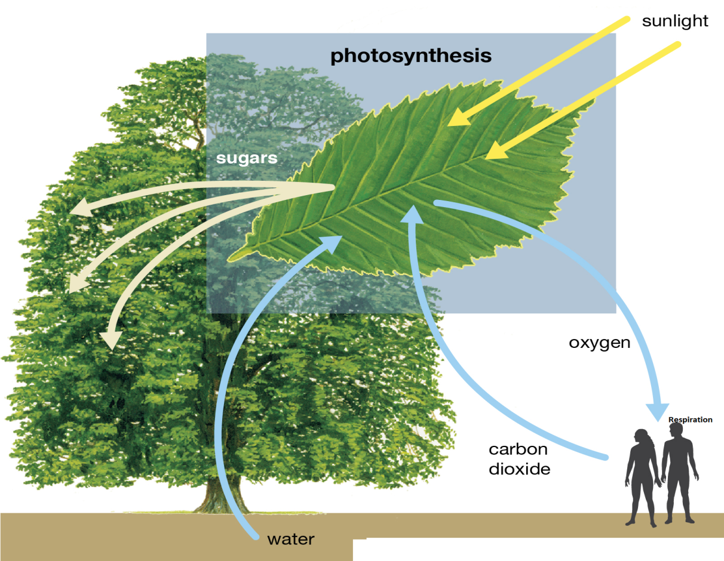-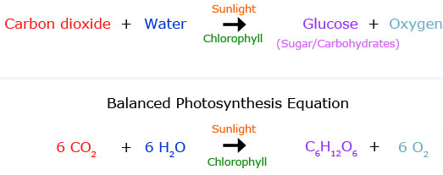

-----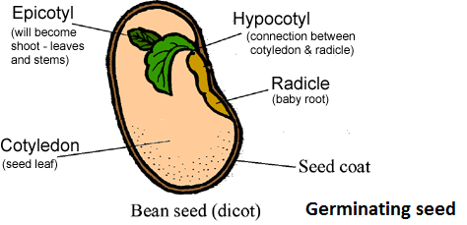

1. Air is used for drying of crops such as cured tobacco (burley)
2. -Wind helps in pollination of plants
3. Wind helps in seed dispersal
4. Wind is used for driving windmills.

**PROBLEMS ASSOCIATED WITH WIND IN AGRICULTURE**

The following are the negative effects of wind in agriculture

1. It causes plant lodging.
2. I-t transmits diseases and pests.
3. It causes soil erosion
4. It increases the rate of evapotranspiratin (loss of water bodies, soil and plants).
5. I--t -disturbs grazing animals.
6. It damages buildings.

**SUNLIGHT**

Sunlight is defined as the light that comes from the sun.

**IMP--ORTANCE OF SUNLIGHT IN AGRICULTURE**

1. It- is used by the plants for photosynthesis. This is the food making process whereby green plants combine water with carbon dioxide using light to produce glucose and release oxygen to the atmosphere.

-----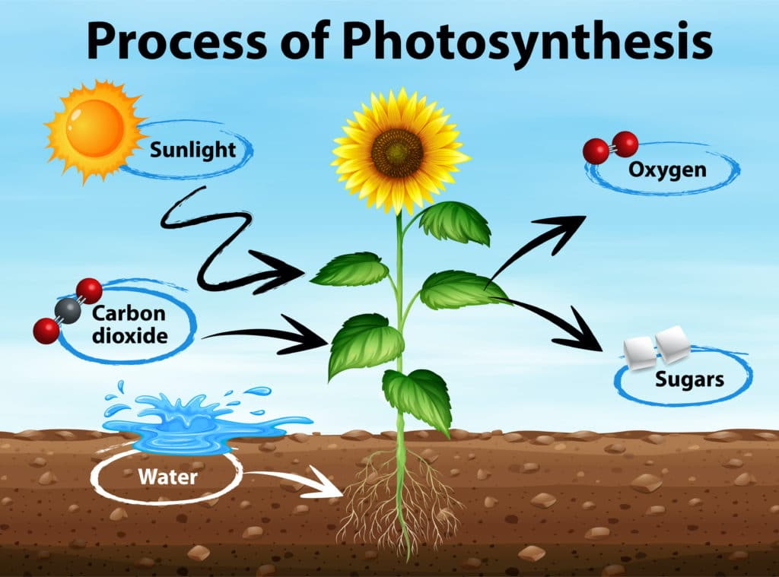

1. It is the source of heat energy for proper drying of crops.
2. It provides heat necessary for controlling some pests such as eelworms.

**- WILDLIFE**

Wild l-ife is the term that is used to describe undomesticated animals and plants.

**IMPORTANCE OF WILDLIFE**

1. It is the source of income.
2. It is a source of foreign exchange mostly through tourism.
3. It prevents the effects of climate change
4. It maintains the ecosystem
5. It is a reserve for biodiversity.

**-- SOIL**

Soil refers to the top lose materials covering the earth’s surface.

**IMP-ORTANCE OF SOIL INAGRICULTURE PRODUCTION**

1. It anchors plants
2. It provides nutrients to the plants.
3. It provides soil water to the plants.
4. It keeps warm for the seed germination, dissolution of nutrients and microbial activities.
5. It is a habitat for soil organisms responsible for decomposition of organic -matter.
6. It provides raw materials for the construction of agriculture infrastructure.

**MINERALS**

A mineral is an element or chemical compound that is normally crystalline and that has been formed as a result of geological processes.

**IMPORTANCE OF MINERALS IN AGRICULTURE**

1. They are absorbed by plants for their normal growth and yielding.
2. Dietary minerals are used by humans for their normal body functioning so that they are fit for agricultural operations.
3. Some minerals like coal are used as a source of energy needed on a farm, for example, heat for curing tobacco.
4. The-y are source of income through export so that as country, Malawi can import agricultural products which are not manufactured locally

**IN WHAT WAYS MAY THE FOLLOWING NATURAL RESOURCES BE DEPLETED?**

1. **WATER**

**Water can be depleted in the following ways:**

1. **-Evaporation**

Water from the soil and water bodies like rivers, lakes and oceans changes into gaseous water and goes into the air.

1. **Transpiration**

Transpiration is the loss of water in form of vapour. It should be noted that water lost by plants is first absorbed from the soil.

1. **Irrigation**

Irrigation occurs when water from reservoirs is used to grow crops.

1. **Domestic use**

Water is used by human beings for various domestic activities.

1. **AIR**

Human activity contributes to the availability of harmful and unnecessary gases in the atmosphere in the following ways

1. Dust which is often a by-product agricultural processes.
2. Biomass burning produces a combination of organic droplets and soot particles.
3. Industrial processes produce wide variety of gases depending on what is being burned in the manufacturing processes.
4. Exhaust emissions from different transport systems like tracks, locomotives and cars pollute the air.
5. **VEGETATION**

**Vegetation can be reduced mainly due to human activities such as**

1. Opening new farms.
2. Clearing land for construction of buildings, roads and various infrastructures
3. Fuel wood
4. Timber and poles
5. Bushfires
6. **SOIL**

* Soil can be lost through soil erosion.
* Soil erosion refers to the washing away of the top loose material either by water or wind.
* Water is the major agent of soil erosion in Malawi

**WHAT ARE THE TYPES OF SOIL EROSION**

The following are the types of soil erosion caused by water

1. **SPLASH EROSION**

This is the type of soil erosion that occurs due to raindrop impact. Raindrops displace soil particles as they hit the ground.

1. **SHEET EROSION**

This is where a large body of shallow water runs down the slope carrying away with it the top soil.

1. **RILL EROSION**

This is the type of soil erosion that causes small streams due to surface runoff after rainfall dig small channels called rills on the ground**.**

1. **GULLY EROSION**

This is the most serious type of soil erosion that occurs when the rill erosions are left unchecked thereby causing large channels being made on the ground**.**

**WIND EROSION**

Wind erosion may be caused by whirl wind.

1. **WILDLIFE**

Wildlife can be depleted in the following ways:

1. **Deforestation**

As human population increases, so does the demand for land for settlement and agriculture. As the result, people may have very little option but to clear the land by felling the trees. They also cut down trees for fuel wood and construction.

1. **Poaching and hunting**

Human beings have been hunters of animals for food since time immemorial; as a result animals have become fewer.

1. **Wildfire**

The setting of bushfire kills vegetation and animals.

1. **Encroachment in protected areas**

This caused when people either open garden or clear such as land for settlement.

1. **MINERALS**

* As crops grow in the garden, these, make use of minerals. The higher the yield realized from field, the higher the amount of nutrients used up by the crops.-
* Soil loses mineral salts in the following ways

1. **Plant uptake**
2. **Soil erosion**

Agents of soil erosion such as water and wind do not only take soil particles, they also take mineral salts which they hold.

1. **Leaching**

This is when dissolved mineral salts are taken deep into soil where plant roots cannot reach.

1. Formation of compounds which are not used by plants like aluminum mining.

**CONSERVATION OF NATURAL RESOURCES**

Conservation of natural resources refers to the wise use of the earth’s resources by humanity. It involves proper utilization of these resources to avoid depletion or destruction.

**WAYS OF CONSERVING NATURAL RESOURCES**.

1. **SOIL CONSERVATION**

Soil conservation is a set of management strategies for prevention of soil being eroded from the earth’s surface.

**CULTURAL METHODS OF SOIL CONSERVATION**

1. **Crop rotation**

* Crop rotation is the practice of growing a series of different type of crop in same area in subsequent seasons**.**
* Land must be demarcated into plots where the different crops are grown separately in the next season; the plots are allocated with different crops. See the diagram below that illustrate crop rotation.

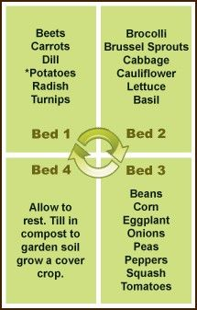

1. **Correct plant population**

A plot can have correct plant population if the following are correct

* Spacing between rows or ridges.
* Spacing between plants
* Number of plants per station. Correct plant population conserve soil by ensuring complete soil coverage so that soil is protected well from raindrops impacts and running water, the result is that the water sinks into the soil without causing erosion.

1. **Application of organic matter**

Organic matter loses the soil particles so that when it rains, water sinks. The volume of soil also increases so that it can hold a great volume of water below it overflows.

1. **Controlled grazing**

This ensures that pasture is not overgrazed and land does not lose the grass which protects the soil from erosion.

1. **Zero or minimum tillage**

Zero tillage refers to the way of planting crops from year to year without disturbing the soil through ploughing. No till increases the amount of water and organic matter and organic matter in the soil which decreases erosion.

1. **Correct land use**

Every land is allocated with an agricultural activity which will protect the land. For example, a hilly area needs not to be opened to arable crops but to tree or perennial crops like teas to avoid erosion.

**Biological method of soil conservation**

Biological method of soil conservation involves planting vegetation like trees and grass on bare land with the aim to ensure that soil is not exposed to agents of soil erosion.

**Physical methods of soil conservation**

This involves building structure such as terraces, contour or graded bands, ridges across the slope, box ridges, storm drains and dams. The purpose is to hold rain water and allow it to sink while at the same allowing excess water to drain away from the field of crop without being erosive.

1. **WATER CONSERVATION**

Water can be conserved using the following methods of conservation

1. **Cultural method of conserving water**

* These m-ay include crop rotation, correct plant population, controlled grazing, zero grazing and correct land use.
* These methods of soil conservation aim at ensuring that there is always adequate soil coverage of the soil so that when it rains, most of the water is trapped and forced to infiltrate into the soil.

1. **Biological method of water conservation**

* This depends on planting trees on bare land. People are discouraged from setting bushfires and wanton cutting down of trees.
* Vegetation helps to open up soil, trap running water thereby increasing rate of water infiltration.

1. **Physical methods of water conservation**

* These methods make up of physical structure such as box ridges, contour bands, dams, storm drains and ridges across the slope. These structures trap and hold water and increase infiltration.

1. **AIR CONSERVATION**

* Air conservation refers to the keeping of air free from pollution. It involves protecting and cleaning of the earth’s air supply.

**WAYS OF AIR CONSERVATION**

Air can be conserved in the following ways

1. Restricting the use of chlorofluorocarbons. These materials are produced in industries which are used mainly in refrigerants and conditioners
2. Conservation of vegetation which use up carbon dioxide for photosynthesis thereby cleaning the atmosphere gases. Vegetation also covers up the and reduces d-us--t.
3. Avoiding bushfires which emits smoke and other gases.
4. Avoiding smoke producing vehicles and locomotives.

**EFFECTS OF RAPID POPULATION ONNATURAL RESOURCES**

1. It leads t-o increase in demand for arable land and this result into land degradation due to over cultivation.
2. Decline in land productivity and reduction in forest cover due to increase in population.
3. Pollution of water, air and land because of the wastes from industries and urban cities.
4. Deforestation as people convert it too arable land for settlement and farming.
5. Encroachment of wetland and marginal land which are not originally suited for cultivation.
6. Desertification results from human activities such as overgrazing due to overstocking; deforestation and poor agricultural practices like slash and burn system which depletes vegetative cover.

**CHAPTER TWO: AGRICULTURAL RESEARCH**

**Agricultural research is defined as:**

1. The scientific and systematic procedure of finding solution to agricultural problems.
2. A formal work undertaken systematically to increase knowledge of garniture, solve new or existing problem, develop new theories and test the validity of instruments or procedure.

**IMPORTANCE OF AGRICULTURAL RESEARCH**

1. It helps to come up with high yielding varieties of crops and breeds of livestock in order to increase food procedure thereby reducing hunger.
2. It helps in coming up with better storage facilities in order to reduce post harvest storage losses so that farmers can sell excess harvest for cash.
3. It can help to increase productivity so thereby making other land to be used for other agricultural activities such as livestock.
4. It helps to come with the new technology to enhance the production of high yields.
5. It helps to develop solution to existing problem such as developing variety which can resist against pest and diseases. For example maize is genetically modified to control stalk borer.
6. It helps to determine suitable ecological conditions for various crops and livestock.
7. It helps to carry out efficacy test on pesticides, herbicides or fungicides to -determine the most suitable for crop production.

**EXAMPLES OF AGRICULTURAL PROBLEMS REQUIRING RESEARCH**

These include

1. Low quantity of crop and livestock yields.
2. Low quality of crop and livestock products.
3. High susceptibility of crop and livestock to pest , disease and parasites
4. Spoilage of agricultural produce before consumption
5. Inadaptability to prevailing ecological conditions
6. Effectiveness and ineffectiveness of agrochemicals
7. Land husbandry so that land continue to be fertile without losing its fertility.
8. Crop husbandry practices -weeding, fertilizer application, pest and disease control, storage and processing
9. Livestock breeds so that new breeds which can grown quickly while fed on small quantities of feed, resists various disease, pests and parasites.
10. Crop varieties so that new varieties which can produce high yield from small hectare are found.
11. Livestock husbandry practices like new feeding methods, advanced housing, new disease and pest control techniques.

**AGRICULTUTAL TECHNOLOGY**

* Agricultural technology refers to new agricultural ideas and inventions which increase agricultural production.
* Technology and Research are related in the sense that research brings new ideas which are in them technology. For example, local varieties to new varieties of crops, hand hoes to ox-drawn and tractor drawn ploughs etc.

**STAGES IN SCIENTIFIC APPROACH TO AGRICULTURAL RESEARCH**

These include

1. **Problem identification**

* A problem could be faced by farmers could of the so many fertilizers available, what could be the best type of fertilizers for maize production.
* Lack or failure of DSP fertilizers during planting results in slow growth rate of maize.

1. **Hypothesis formulation**

* This is an answer which will be proved or disapproved.

**Example:** planting maize using DSP fertilizers promotes fast growth

1. **Aim**

* Clearly state aims of the experiment. This is what you want to achieve at the end of the day.

**Example:** To determine the effects of planting maize using DSP fertilizer on root growth

1. **Experimental design**

This means planning the layout of the experiment, that is, how the experiment will appear in the field.

In other words, an experimental design is a plan that is used to assign the experimental units to treatment conditions.

**Explain two types of experimental designs.**

1. **Randomised block design**

This is an experimental design where the units to be used when conducting an experiment are arranged in groups known as blocks to ensure greater level of accuracy is achieved. Each treatment appears one in each block a-nd treatments are randomly allocated to the block.

**Example**

A researcher wanted to find out the effects of three levels of CAN fertilizers (100kg/ha, 150kg/ha, 200kg/ha) on the yield of four hybrids of maize (A, B and C). Design an experiment using randomized block design.

|  |  |  |  |
| --- | --- | --- | --- |
| Variety of maize | Level of CAN application | | |
| A | 100kg/ha | 150kg/ha | 200kg/ha |
| B | 150kg/ha | 200kg/ha | 100kg/ha |
| C | 200kg/ha | 100kg/ha | 150kg/ha |

The yield of maize, kg/ha, is then filled for each variety of maize in response to each level of CAN application.

1. **Latin square design**

This is an experimental design used when the experimenter wants to manage the units in an experiment that are related to rows and columns. The treatments are assigned once and at random on each row and columns. There are equal number of rows and columns and the treatment applied.

Each treatment appear once in a block and each treatment appears once in a block and also once in plot.

**An example is shown below**

|  |  |  |  |  |  |
| --- | --- | --- | --- | --- | --- |
| **A** | **B** | **C** | **D** | **E** | **F** |
| **B** | **C** | **D** | **E** | **F** | **A** |
| **C** | **D** | **E** | **F** | **A** | **B** |
| **D** | **E** | **F** | **A** | **B** | **C** |
| **E** | **F** | **A** | **B** | **C** | **D** |
| **F** | **A** | **B** | **C** | **D** | **E** |

**QUESTION FOR REVIEW**

Table below shows a wrong randomized block design of an experiment on maize variety trial conducted by students at a certain secondary school. Use it to answer the questions that follow.

|  |  |  |  |
| --- | --- | --- | --- |
|  | **Block 1** | **Block 2** | **Block 3** |
| **Plot 1** | **NSCM 41** | **MH 16** | **NSCM 41** |
| **Plot 2** | **Local Maize** | **MH 12** | **Local Maize** |
| **Plot 3** | **MH 16** | **Local Maize** | **MH 12** |
| **Plot 4** | **MH 12** | **MH 16** | **NSCM 41** |

**Required**

1. **Mention four mistakes in the experimental design.**
2. NSCM 41 is repeated in plot 1
3. Local maize is repeated in plot 2
4. MH 16 is repeated in block 2
5. NSCM is repeated in block 3
6. **Using the information in the table above, lay out the correct field plan.**

|  |  |  |  |
| --- | --- | --- | --- |
|  | Block 1 | Block 2 | Block 3 |
| Plot 1 | NSCM 41 | MH 16 | Local Maize |
| Plot 2 | -MH 12 | NSCM 41 | MH16 |
| Plot 3 | Local Maize | MH12 | NSCM 41 |
| Plot 4 | MH16 | Local Maize | MH12 |

**FACTORS CONSIDERED WHEN LAYING OUT EXPERIMENTS**

1. **Treatments**

This is a variable or feature or quality which change or differs or vary. For example of fertilizer trial it could be **“type of fertilizer under study’**

This is what is applied on the experimental units. The person conducting the experiment should choose a variety of suitable treatments to apply on the experimental units so as to monitor its effect on other units.

Treatments are carried out with a view of solving a hypothesis. A farmer can plant hybrid maize at different time intervals in the rainy season so as to determine the most suitable time for planting. In this case, different time intervals are the treatments given to each experimental unit.

1. **Randomisation**

* Randomisation is the practice of assigning objects of study to an experimental unit by chance.
* Randomization is the true way of creating homogenous treatment units which helps to eliminate any form of potential bias from the researcher.
* In fact, the importance of randomisation is to avoid bias or favour one treatment when allocating the treatments into the plots.
* The following are methods of randomizing experimental designs

1. **Completely randomized design**

This is where all the objects or subjects of study are assigned to groups completely at random.

1. **Randomised block design**

This is where the subjects or objects are first divided into homogenous units, known as blocks, before they are randomly assigned to treatment groups.

**The techniques/methods of randomizing treatments**

1. **Tossing a coin**

This is used if there are two treatments since a coin has two sides.

1. **Throwing a dice**

This is used when there are six treatments since a dice has six sides**.**

1. **Drawing pieces of paper from a bag.**

Each treatment is written on a separate piece of paper and folded. Each paper is picked in turns and allocated to a block. The number of papers should be equal to number of treatments.

1. **Using random number tables**

This where the numbers are written in tables and they are generated by -computers.

1. **Replication-** This involves repetition of the basic experiment. This means repeating of the experiment in different plots of the same field or at another place. This is illustrated by the table below.

|  |  |  |  |
| --- | --- | --- | --- |
| **Plot** | **Block 1** | **Block 2** | **Block 3** |
| 1 | CAN | Urea | Sulphate of Ammonia |
| 2- | Urea- | Sulphate of Ammonia | CAN |
| 3 | Sulphate of Ammonia | CAN | Urea |

**The following are benefits of replication in the agricultural experimentation.**

1. Secures more accurate estimates of the experiment error.
2. Decreases experimental errors thus increasing precision
3. Obtains a more precise estimate of the mean effect of a treatment.

**Control Experiment**

This is a plot which serves as a comparison treatment against all other treatments. This is- familiar to the researcher.

1. **Carrying out the experiment**

This involves conducting an experiment in the field where crop husbandry practices are going to be same except treatments under study.

1. **Data collection and recording**
2. **Collecting data**

* Data is anything given as a fact on which research conclusions will be based.
* Therefore, data collection involves gathering data. Data can be collected on leaf colour, plant height, number of flowers, branching, leaf length and breadth, stem circumference, plant lodging, disease and pest incidence.

This data can be collected by **observations** and **measurement.**

* The techniques/tools which are used in data collection

1. Observation
2. Questionnaires
3. Interviews
4. Document analysis.

* In collecting data ensure the following:

1. collect accurate data
2. Record the -data in a book to serve as reference.
3. Use proper tools for carrying out measurements such as weight, height and length.
4. **Recording data**

* This involves presenting the collected data in forms of tables, graphs and figures. Therefore the forms of data presentation include

1. Graphs
2. Tables
3. Figures

* **Tables** are used- to record precise numerical data.
* A good table should have the following

1. Table number
2. Title
3. Column headings
4. Row headings
5. Body of the table
6. Foot notes

* A table should self-explanatory and clearly show the main points. Units of measurements should be well indicated such as cm, kg, tones etc and figures should be rounded off to two significant figures such as 8.27 rather than 8.2568cm.

Below is a table for recording data

|  |  |  |
| --- | --- | --- |
| **Plot 1** | **Block 1** | **Yields in kg** |
| 1 | CAN | 6,000 |
| 2 | Urea | 11,000 |
| 3 | Sulphate of Ammonia | 5,500 |
| 4 | No fertilizer | 600 |

* **Graphs** are used for illustrating trends and relationships among sets of variables. The following are the different types of graphs that are used in presenting data- collected during agricultural research

**EXAMPLE**

|  |  |  |
| --- | --- | --- |
| **Plot 1** | **Block 1** | **Yields in kg** |
| 1- | CAN | 6,000 |
| 2- | Urea | 11,000 |
| 3 | Sulphate of Ammonia | 5,500 |
| 4 | No fertilizer | 600 |

The data provided in table above can be presented in the form of line graphs, pie chart and bar or histogram as shown below.

1. **Line graphs-** show relationship among data

**EXAMPLE**

Table 1 shows live weight gained for two exotic breeds of cattle that were stall fed using same amount of silage for 40 days. Weighing was done at 5 days interval. Use it to answer the questions that follow.

|  |  |  |
| --- | --- | --- |
| **Days** | **Breed A**  **(Live weight gained in kg)** | **Breed B**  **(Live weight gained in kg)** |
| 5 | 10 | 14 |
| 10 | 20 | 18 |
| 15 | 30 | 26 |
| 20 | 36 | 40 |
| 25- | 40 | 46 |
| 30- | 44 | 50 |
| 35 | 50 | 60 |
| 40 | 56 | 70 |

1. Draw two line graphs on the same axes to show the live weight gained in the two cattle breeds.

1. What is the difference in live weight gained between the two cattle breeds on day 33?

Cattle Breed A gained 44 kg while Breed B gained 62kgs.

1. **Bars and histograms-** used to compare quantities

Table below shows the yields obtained from the application CAN, Urea, Sulphate of Ammonia and no fertilizer application.

|  |  |  |
| --- | --- | --- |
| **Plot 1** | **Block 1** | **Yields in kg** |
| 1 | CAN | 6,000 |
| 2 | Urea | 11,000- |
| 3 | Sulphate of Ammonia | 5,500 |
| 4 | No fertilizer | 600 |

Draw- -the histogram to represents the information.

--

1. **Pie charts**- show proportions of a whole component as wedges of a circle. A percentage must be assigned to the segment or wedge. This can be illustrated in form of pie chart below

-

1. **Flow charts** - shows the process of a complex system.
2. **Figures** -are used to show vivid evidence of research findings and include line drawings and photographs.-
3. **Data analysis**

This deals with the organization, interpretation and presentation of collected data.

The two techniques of data analysis include-

1. **Descriptive analysis**

* This involves analyzing the data using central tendencies such as calculating the mean, median and mode. This describes how close a measure is to the central measure. It also involves dispersions such as calculating range, quartile deviation and standard deviation, to describe a group of subjects. This helps to describe how far a measure is from the central measure.
* It may involves calculating percentage such as germination percentages, survival percentage
* Calculating the range-

1. **Inferential analysis-**

This is where statistics are used to draw conclusions about the population from which the -sample was taken.

1. **Data evaluation**

This is the discussion of the results and describing the implications of the findings. The researcher mainly identifies and interprets the major findings that relate directly to the study objectives. The researcher states and explains how the study helps to resolve the original problem and suggests improvements

In other words, data evaluation is the summary of the findings in which the researcher discusses, concludes and recommended the findings to the farmer.

1. **Report writing**

This is to inform the user about the findings, i.e. the farmer of the new technology that has been identified through the research. It helps other research-hers not to repeat the experiment but continue from where it was stopped.

**PARTS OF A REPORT OF AN AGRICULTURAL EXPERIMENT**

1. **Title**

* This is the statement that describes what is being investigated. It appears on the first page of the report.
* It gives a summary of the main idea of the research in a simplified and clear way.

1. **Introduction**

* Introduction is usually the first chapter in a report. It provides the basis of the study. It gives an overview of the research, highlighting the background information, statement of the problem being analyses, the significance and scope of the research.

1. **Aim/purpose of the research**

* This is a road statement of what the study/research intends to find out or achieve. It elaborates on the information mentioned in the title by giving a quick overview of the study.

1. **Objective-s**

These are -the specific aims of the study. They show specific outcomes that specify more directly what the research is going to do.

A good research objective should be:

1. Specific
2. Measurable
3. Attainable
4. Realistic
5. Time bound
6. Clearly indicate the variables to be investigated and their relationship. For example determining the relationship between depth of planting of maize and the yield of maize in Mzimba district in Malawi.
7. **Materials and methods**

This clearly indicates all the materials and equipments that were used in carrying out the research such as hoes, machines, fertilizers, manure, maize seeds etc.

1. **Design of the experiment**

This describes the methodology and methods that the study adopted as well as reasons for the choice. There are several designs that can be used depending on the set objectives of study.

The researcher should:

1. Identify and name the research design
2. Briefly and in concise terms, describe the design.
3. Justify for the use of the design.
4. Explain how the design will be used.
5. **Results**

This gives -a detailed description of the results obtained after data analysis. The data collected can be presented in form of tables and figures.

There are two kinds of the data that can be collected in a study

1. **Quantitative data-** It is got from measurable variables. These can be measured using a scale that shows how much of the characteristics is present. These variables include height of the seedlings, size of the cob, yield of maize per unit area,
2. **Qualitative data**- This indicates the objects under study and individual differences that a researcher can find in a particular way.

When presenting findings, the researcher restates each objective and then includes all the findings related to that objective.

The data collected should be analyzed using a suitable technique and -presented in an acceptable and conventional manner.

1. **Discussion of the results**

This involves the interpretation of findings in the research objectives. The following procedure should be followed

1. Give a brief summary of the problem that was being investigated.
2. Present the major findings under each objective.
3. Discuss the possible reasons why the results occurred in that way.
4. Make theoretical interpretations of the findings.
5. **Conclusion**

On completion of the study, the researcher will draw conclusions based on the information presented and analyzed with respect to the research problem and the main research objectives.

1. **Recommendations**

These present the possible solutions to the research hypothesis based on the findings of the research. The recommendations should have a target group. This means that what should is to be done, how and when**.**

**CHAPTER 3: AGRICULTURAL TECHNOLOGY**

* Agricultural technology refers to techniques that are applied to crop and or livestock production to enhance growth and productivity.
* Agricultural technology also refers to tools, equipment, machinery and structure used in agricultural production. Examples of these tools, machinery include
* Ploughs
* Mowers
* Harrows
* Combine harvesters
* Tractors
* Incubators
* Brooders
* Sprayers
* Examples of agricultural techniques include

1. Use of hybrid seeds
2. Use of resistant varieties
3. Pruning
4. Cropping systems
5. Feeding
6. Housing
7. Machine milking
8. Irrigation etc.

**IMPORTANCE OF AGRICULTURAL TECHNOLOGY**

1. Increase quantity of produce through the use of manure and inorganic fertilizers.
2. Increase quality of produce through the cultivation of indigenous crops and keeping indigenous breeds of animals which are more resistant to diseases.
3. Reduce cost of production by encouraging improvisation of tools rather than buying.
4. Increase production life span through the use of quality certified seeds.
5. Improvement in adaptability to local ecological set-ups.
6. Enhances food security by ensuring that the food produced by farmers is enough for the nation.
7. Improves transport and communication by maintaining proper road networks.
8. Improves bilateral, international relationship which is important especially when loans or aids are required by the nation.
9. Reduces crop or livestock produce through better post harvest technology.
10. Improves environmental conservation by encouraging farming practices such as cultivating across the slope, soil erosion control, afforestation etc.

**WHAT IS THE LINK BETWEEN AGRICULTURAL RESEARCH AND AGRICULTURAL TECHNOLOGY?**

Agricultural technology refers to research outputs that have been tested and proven to provide solutions to agricultural problems. While the main objective of agricultural research is to provide solutions to problems that affect agricultural production. The knowledge from research in the agricultural technology forms the basis of agricultural productivity such as improved crop yielding variety, improved keeping of quality fruits, improved resistance to both crop and livestock diseases etc.

**FARM STRUCTURES**

* Farm structures refer to different types of physical constructions that are put up in a farm for the purpose of livestock and crop production to increase efficiency in agricultural production.
* The five categories of farm structures include

1. **Crop storage**

* These are structures used to preserve harvested crop produce for future use or during a time when the weather cannot allow production**.**
* The two storage structures include

1. **Traditional storage facilities**

These include underground pits, clay pots, grass baskets and traditional granaries made from local materials.

1. **Modern storage facilities**

These include grain tanks and drums, grain silos, modern granary, sacks and portable metallic silos.

1. **Crop processing structures**

This involves changing crops from one form to a more valuable or one that can last longer.

Some of the processing structures include

1. **Tobacco burns** for curing tobacco
2. **Silos** for ensiling vegetable for silage preparation.

The most common types of silos are

* **Pit or Trench silo**- This is constructed below the ground level and constructed with sloping walls made of timber.
* **Tower silo**- This is made of concrete above the ground with perpendicular on three sides, leaving one side open for the filling and removal of the silage.
* **Clamp or bunker silo-** This is constructed using timber above the ground level with its sides or the walls slanted.

1. Milk processing plant into other products such as yoghurt, ghee and powdered milk.

**IMPORTANT IMPLEMENTS IN CROP PROCESSING**

|  |  |
| --- | --- |
| **Implements** | **Uses** |
| Chaff cutter | It is used to chop straw, hay, or Napier grass into small pieces suitable for feeding livestock. |
| Oil press  (Oil pressing machine) | It is used to extract oil from oil seeds to process cooking oils, make soaps etc |
| Silage(forage) harvester | It is used to harvest forage plants to make silage |

1. **Animal housing structures**

* These are structures used for housing the livestock.
* They include crushes, dips, spray race, calf pens, dairy shed or parlour, poultry houses (such as deep litter, battery cages, runs, folds, coops, rabbit hutches or pig sty, fish ponds, zero grazing unit and beehives.

|  |  |
| --- | --- |
| **Housing structure** | **Uses** |
| Battery cage | To house birds under the intensive system of poultry production. |
| Coops | They are used for rearing hens that are brooding |
| Deep litter | It is a poultry house where birds are confined |
| Fish ponds | They are used for rearing fish.  NB: They are constructed near a water sources. |
| Zero grazing unit | This is used for housing livestock in total confinement since the animal is fed in the unit and rarely moved out |
| Calf pens | These are used for housing calves. |
| Rabbit hutches | These are used for keeping rabbits |
| Piggery/pig sty | They are used for housing pigs. |
| Beehives | They are used for keeping bees. |

1. **Farm equipment and tools**

* These are used to carry out operations and tasks in the far during crop and livestock production.

**IMPORTANCE OF USING FARM TOOLS AND EQUIPMENT**

1. To increase efficiency and make farm operations easier.
2. To minimize injuries to livestock.
3. To enhance milk production through sing machine milking equipment.

**CATEGORIES OF FARM TOOLS AND EQUIPMENT**

1. **GARDEN TOOLS AND EQUIPMENT**

* These are tools and equipment that a farmer needs for crop production
* Examples include the following:

|  |  |
| --- | --- |
| **Tool/implement** | **uses** |
| **Machete** | * Cutting down small bushes, shrubs and weeds * Clearing land of small trees or shrubs * Harvesting crops like sugar cane * Shaping wooden handles of hoes |
| **Axe** | * Cutting tree stumps * Felling trees during land preparation * Splitting trees into logs for construction of farm structures |
| **Mattock or pick axe** | * Digging out stones and hard soil * Uprooting tree stumps before ploughing * Cutting tree roots during land preparation |
| **Hoe** | * Cultivation of land when preparing seedbed and during weeding * Digging foundation of farm structures and buildings * Preparing planting furrows and holes |
| **Forked hoe** | * Removing underground perennial weeds such as couch grass. * Digging hard, stony, wet or muddy soils * Harvesting tuber crops such as Irish potatoes |
| **Spade** | * Digging in stone places and in coffee plantations where use of hoe can damage coffee roots * Removing soil when digging holes and applying manure |
| **Wheelbarrow** | * For transporting small loads such as sand, bags of seeds, seedlings during transplanting and bags of fertilizers within a short distance |
| **Watering cane** | * For watering seedlings in seed boxes, potted plants, nursery beds, transplanted seedlings and seeds. |
| **Rake** | * Removing uprooted roots and stems, crop residues, seedbed for growing vegetables etc * Levelling and finishing off the seedbed * Collecting mowed grass * Spreading inorganic manures on the seedbed |
| **Soil Auger** | * Soil sampling during testing. * Digging holes for fixing fence posts |
| **Knapsack sprayer** | * Applying agrochemicals such as foliar fertilizers, herbicides or pesticides to crops efficiently, economically and safely. |
| **Sprinkler** | * Applying water to crops in overhead irrigation |
| **Garden shear** | * Trimming hedges and shrubs in the farm |
| **Pruning saw** | * Pruning perennial crops like coffee, citrus fruits and pollarding trees |
| **Secateur** | * Pruning crops like coffee and cutting flowers. * **NB**: Pruning involves cutting unwanted branches and suckers. |
| **Garden trowel/**  **Hand trowel** | * Loosening the soil * Apply old engine shallow holes * Lifting out seedlings from the nursery beds during transplanting |
| **Manure fork** | * Turning and collecting manure |
| **Pruning hook** | * Cutting branches of tall trees * Pruning crops like tea |
| **Shovel** | * Scooping loose soil, fertilizer, seeds and sand. |

**MAINTENANCE OF** **GARDEN TOOLS AND EQUIPMENT**

1. Apply oil on the metallic parts to prevent rusting
2. Store properly in dry place
3. Replace worn out handles
4. Repair any broken handles or parts
5. Clean after use
6. Straighten bent parts
7. Ensure they are firm
8. Sharpen the edges of edges of other implements/tools
9. Unblock the nozzles for sprayers when blocked
10. Grease the moving parts to avoid friction

* Fixing loose handles.

1. **LIVESTOCK PRODUCTION TOOLS AND EQUIPMENTS**

* These are tools and equipments used for routine practices in livestock.
* Examples of these tools and implements include

|  |  |
| --- | --- |
| **Elastrator** | * Enlarging the rubber ring during castration of small livestock * Dehorning * Docking lambs |
| **Burdizzo** | * It is used for bloodless castration of bulls, rams and Billy goats by snapping the spermatic cords. |
| **Syringes and hypodermic needles** | * Administering injections and taking blood samples * Administering liquid drugs such as vaccines * Infusing antibiotics into the teat canal for prevention of mastitis. |
| **Halter** | * Restraining cattle. It prevents choking of the animal and ensures complete control of the animal. * Leading cattle during exhibitions such as agricultural shows |
| **Hoof trimmer** | * Cutting or trimming overgrown hooves of livestock such as cattle, sheep and goats |
| **Strip cup** | * It is used for detecting mastitis in a cow. Milk from animals with mastitis shows clots when placed on the black plate. |
| **Trocar& canula** | * It is used to relieve bloat in livestock through piercing the rumen to release gases. |
| **Hand broom** | * Washing concrete floors in the dairy shed or livestock houses. |
| **Wool shears** | * Clipping or shaving wool in sheep. |
| **Ear notcher** | * Cutting identification shapes on the ears of an animal for example in cattle. |
| **Bull ring & lead stick** | * It is used for restraining bulls. It gives the handler a safe distance from vicious bulls which can be dangerous on coming closer to the handler. |
| **Stir-up/bucket pump** | * It is used for hand spraying animals against sticks |
| **Milk churn** | * Storing milk. * Transporting. |
| **Milk strainer or sieve** | * Removing any visible foreign materials from the milk such as dirt and animal hair. |
| **Hot iron** | * It is a device used to apply heat to the born-buds to destroy the cells and hence prevent horn growth from these buds |
| **Teeth clipper** | * Cutting off wolf-teeth in piglets. |
| **Drenching/dosing gun** | * Oral administration of liquid drugs to animals during deworming. |
| **Bolus gun** | * It is used for deworming livestock orally using solid drugs/tablets. |
| **Dehorning wire** | * Dehorning mature livestock. The friction created produces heat which blocks blood vessels and therefore minimises bleeding. |
| **Dehorning iron** | * It is used to debud or dehorn young horned animals. In this case, the cells that produce horns are killed. |
| **Chaff cutter** | * Chopping straw, hay or Napier grass into small pieces suitable for feeding livestock. |

**MAINTENANCE OF LIVESTOCK TOOLS AND IMPLEMENTS**

1. Apply oil on the metallic parts to prevent rusting
2. Store properly in a tool cabinet
3. Store properly in dry place
4. Replace worn out handles
5. Repair any broken handles or parts
6. Clean and disinfect after use
7. Ensure they are firm
8. Sharpen the edges of edges of other implements/tools
9. Unblock the nozzles for sprayers when blocked
10. Grease the moving parts to avoid friction
11. Fixing loose handles.
12. **Workshop tools and equipment**

* These are tools and equipment which are used for the construction and maintenance of farm structures.
* These are classified

1. **WOODWORK TOOLS AND EQUIPMENT**

These are carpentry tools mainly used for working on wood or timber.

Examples include

|  |  |
| --- | --- |
| **Crosscut saw** | * For cutting across the grains of timber |
| **Back saw/Tenon** | * For cutting wood grains in any direction that is along or across the grain * For joinery work in woodwork such as doors * Fine sawing such as doors. * Fine sawing of small pieces of timber |
| **Coping saw** | * Cutting sharp curves in wood |
| **Compass**  **Key hole saw** | * For cutting holes especially key holes. * For cutting curved or irregular shapes in woodwork |
| **Ripsaw** | * For cutting wood along grains * For splitting logs for timber production |
| **Bow saw** | * For cutting or sawing especially curves. |
| **Wood chisel** | * Trimming off rough edges on wood * Making grooves on wood * Making grooves for joints in wood |
| **Rasp/Wood file** | * Used where more material is to be removed and fast |
| **Marking gauge** | * For marking parallel lines along the edge of the stock in woodwork to indicate the cutting line. |
| **Jack plane** | * For smoothing surfaces in woodwork to produce even surfaces. |
| **Smoothing plane** | * It is used for smoothing surfaces of food. |
| **Plough plane** | * It is used to cut tongues and grooves on the edges of timber so that the two pieces of timber can fit together. |
| **Spoke** | * It is used for smoothing circular work in wood in wood or curved edges. |
| **Sash clamp** | * For fastening parts of wood together such as doors and windows * For holding together pieces of work when performing other tasks such as sawing and cutting timber. |
| **Claw hammer** | * For driving nails into wood and for removing nails from wood. * For straightening nails |
| **Brace and bit** | * It is used for drilling holes in wood. |

1. **METALWORK TOOLS AND EQUIPMENT**

|  |  |
| --- | --- |
| **Hack saw** | For cutting wires and metals |
| **Cold chisel** | For cutting heavy gauge metal sheets  For cutting shapes in metal sheets |
| **Wire brush** | Used to clean rusted surfaces or joints to be soldered. |
| **Soldering gun** | It is used for melting rods  Soldering wires when repairing of fabricating sheets. |
| **Tinsnip** | * For cutting thin sheets of metal and iron |
| **Wire strainer** | For tightening barbed wire during fencing. |
| **Pliers** | * For cutting thin wires * For holding nuts when opening * For holding pieces of metal which cannot be held by hand or using clamps. |

**PLUMBING TOOLS AND EQUIPMENT**

|  |  |
| --- | --- |
| **Pipe wrench** | It is used for opening and closing metal water pipes. |
| **Pipe cutter** | For cutting metal water pipes |
| **Stock and die** | It is used for cutting threads on pipes |
| **Riveting machines** | Joining sheets of metal and wood especially when making chairs by use of a bob rivet. |
| **G-clamp** | For fastening together small pieces of timber  For holding work pieces in the workshop when drilling or cutting. |
| **Mallet** | * Metalwork mallet For shaping thin sheets of metal which could be damaged by using steel hammers * Woodwork mallet is used to drive in wood chisels |
| **Ball-pein harmer** | * For straightening metal sheets and rods * For riveting * For driving in nails. |

**MASONRY TOOLS AND EQUIPMENT**

Masonry includes construction of farm structures using stones, bricks or blocks, cement, sand or concrete mixtures are used to bind the construction rods together.

|  |  |
| --- | --- |
| **Sledge hammer** | * For demolishing farm structures * Store driving pegs into the ground * Oil the metallic parts to prevent rusting |
| **Levelling rod** | * Measures distance in the levelling land. |
| **Spirit level** | * To ascertain levelness or horizontals of a building or wood or metal structures * It is used in construction to ensure the walls are vertical |
| **Mason’s trowel** | * Laying on the mortal during construction. |
| **Wood float**  **or metal float** | * Level or smoothen concrete and mortar. * Hold mortar before it is placed in position. |
| **Crowbar** | * For demolishing a fence or removing the staples. * For tightening barbed wire when fencing. |
| **Plumb bob** | * Checking for perpendicularity of walls in a building during construction. |
| **Tamper** | * It is used for compacting concrete on foundation bases or slab on floor |

**SOURCES OF DANGER IN THE FARM**

These include:

1. Poorly stored agrochemicals
2. Poor arrangement of tools and equipment in workshop.
3. Careless exposure of highly inflammable chemicals such as petrol.
4. Heavy rains washing away bridges and houses.
5. Collapsing buildings.
6. Untrained personnel handling some farm machinery
7. Failure to observe procedure before taking livestock to the dip.
8. Slippery floors in animal houses.
9. Broken pieces of glasses lying in the compound.

**FARM SAFETY RULES**

**These include**

* Seek architectural advice and adopting it in constructions to avoid collapsing of farm structures.
* Use tools correctly and store them in the recommended way and in the recommended places.
* Keep safe distance from others when working using tools and equipment to avoid injuries.
* Dress on the right attire when working with tools and equipment to avoid injuries.
* All the broken tools should be repaired to avoid accidents and increase their efficiency.
* Keep children away from all machinery operations.
* Check farm machineries before work such as brakes, tyre pressure and water.
* Only trained and skilled personnel to should operate specific farm operations
* Agrochemicals containers should be stored out of reach by children.
* Avoid smoking, eating or drinking when spraying agrochemicals.
* Wear protective gloves when handling chemicals.
* Enough light is important especially in the store room to allow visibility.
* Use the tools and equipment.

**IMPORTANCE OF OBSERVING SAFETY RULES WHEN USING FARM STRUCTURES**

* Substandard construction in the farm will be avoided and buildings stay longer.
* When tools are stored properly, they do not rust.
* Broken tools should be repaired to avoid accidents and increase their efficiency.
* It helps to keep the children safe from dangerous chemicals.
* Experts only should be allowed to operate farm machines to avoid injuries.
* Some agrochemicals are inflammable hence avoiding smoking will prevent onset of fires.
* Proper lighting in the farm house prevents accidents.

1. **ROADS AND BRIDGES**

**UTILITY**

* Utility is the ability of an object to satisfy ones wants.
* Examples of utilities include

1. Place
2. Form
3. Time and Ownership

* The farmer requires the produce to be where they are needed at the right time that is, place and time utility.
* Therefore, goods roads should be constructed and bridges should be constructed over rivers to allow communications and transportation throughout the year.

**WAYS OF ENSURING ROADS AND BRIDGES TO REMAIN IN GOOD ORDER**

1. Tarmac roads should be recarpeted when worn out.
2. Earth roads should be graded and marrumed.
3. Vegetation forming canopy over roads should be cleared.
4. Damaged bridges should be repaired and the low ones which allow water to overflow during rainy seasons should be raised.
5. Traffic lights in busy roads should be working condition to minimize traffic jams.
6. There should be dual carriage roads in very busy parts of the country.
7. Drainage channels should be cleared of vegetation and desilted.

**CHAPTER 4: FARM BUSINESS MANAGENENT**

**EXPLAIN BASIC FARM BUSINESS MANAGEMENT CONCEPTS**

1. **Production**

Production involves of available resources to come up a product. During production, inputs such as agro-chemicals, planting materials and farm machinery are used to obtain outputs in terms of products.

For maximum productivity to occur, factors of production must be well harmonized and utilized.

**Importance of agricultural production:**

* Provision of food for rural and urban population.
* Source of direct and indirect employment.
* Production of raw materials for industries.
* Provide market for industrial goods such as farm machinery and agrochemicals.
* Each foreign exchange after exporting farm produce.
* Source of revenue or capital obtained when a farmer sells his or her farm produce.
* Improves the standards of living of the farmer’s household.

1. **Financing**

* Finance refers to money used to run a business, an activity or a project.
* Financing involves making available money or funds for setting up an enterprise, project or a programme.
* Finances are important to the farmer because they are used to buy land, hire labour and buy agricultural inputs.
* Farmers obtain finances from agencies such as
* Commercial banks
* Self-savings
* Grants or donations
* Co-operative societies
* Agricultural financial organization
* Money lending organization.

1. **Budgeting**

* A budget is an estimate of the future expenses and income of a proposed farm plan.
* Budgeting is the process of estimating the results of a proposed farm plan. It is the translation of a physical plan into financial terms.

**IMPORTANCE OF BUDGETING**

* It assists farmers to estimate the required production resources such as labour and capital.
* It is useful document for negotiation of credit from financial institutions.
* It helps to improve predictability in the farming process.
* It helps farmers to identify progress or recess in the farm business based on the set objectives.
* It assists farmers in making sound and urgent decisions when comparing various alternative enterprises.
* It encourages hard work and efficiency so as to meet the set objectives.

**TYPES OF BUDGETING**

The two types of budgeting include

1. **Partial budgeting**

This is the simplest form of farm budgeting which shows the financial implications of proposed minor changes in the farm.

1. **Complete budgeting**

This is the budgeting that involves both variable and fixed inputs and is drawn when there are major changes in the farm or when a new farm is being planned for.

1. **Record keeping**

* Farm managers keep systematic entries of various activities and transactions carried out within the farm.
* Entries showing statements of all transactions within the farm are referred to as **farm records**.

**IMPORTANCE OF FARM RECORDS**

* They help the farmer to carry out proper business planning in future.
* They provide a basis for comparison between successive financial years and with neighbouring farms or with set standards.
* They help a farmer to determine the profitability of various enterprises and to decide on which enterprises to expand or do away with.
* They provide a history of the farm in case the farmer intends to sell it.
* They help the farmer to avoid being overtaxed as tax calculation is based on actual performance of the farm.
* They help to determine whether the farm business is solvent or in deficit.
* They remind the farmer about his or her debtors and creditors so that necessary follow up is done.
* They help in setting insurance claims for any unforeseen eventualities such as fire.
* They form the basis for credit worthiness evaluation of a farm when seeking credit facilities.

**TYPES OF FARM ACCOUNT RECORDS**

These include

* Financial documents
* Books of accounts.
* Financial statements

1. **Business decision making**

* Decision refers to choice or judgement, that you make after thinking and talking about what is the best thing to do.
* A farmer should make an informed or the best choice from the available plans or actions for maximum productivity.

**DESCRIBE THE MAIN FACTORS OF AGRICULTURAL PRODUCTION**

1. **Land**

Land is the most important factor of production. It is important in the following ways

1. Productivity since it is able to sustain crop and livestock production.. It is influenced through capital investment and modern farming techniques such as fertilizer application, pest and disease control, irrigation and soil conservation.
2. It provides the space for construction of farm buildings, agro-industries, dams and mineral deposit reserves.

Farmers can acquire land through the following methods

* Inheritance from relatives or well wishers.
* Buying land from willing sellers.
* Leasing from landlords where the tenant pays a specified amount of money as rent for a given period of time.
* Allocation by the government through settlement schemes.

1. **Labour**

* Labour is defined as human, physical and mental services employed in the production process.
* Two types of labour include

1. **Family labour**

* This is the labour that consists of the farmer and the members of his family.
* The duties are assigned according to the age and ability of the family members by the supervisor who is also the family head.

1. **Hired labour**

* This is the labour employed from outside the family which can either be permanent or casual.
* Permanent labour is employed throughout the year regardless of the activities on the farm. They earn salary at the end of the month.
* Casual labourers are employed on temporary basis, usually at labour peak periods, for example, during harvesting and planting to supplement permanent labour or family labour.
* Labour productivity is expressed in terms **of man-hours, man-days, man weeks, month-months and man-years**. For example, 10 man-hours indicate a piece of work which can be carried out by

1. One person within a period of ten hours.
2. Ten people within a period of one hour.

* Labour efficiency can be improved in the following ways

1. Training the labour force through demonstrations on the farm, workshops and seminars, agricultural shows and field days.
2. Using farm mechanization to perform tasks faster and more efficiently. These machines may include milking machines, combine harvesters, chemical sprayers and planters which help to carry out farm operations faster and more efficiently.
3. Giving incentives to the labourers in order to motivate them to work harder and increase production.

The incentives may include provision of proper housing, transport allowance, work cloths and protective wear, rewarding good workers, proper remuneration and medical insurance.

1. Assigning specific tasks to the labour force basing on labour skills that they have, and should be completed before embarking on another.
2. **Capital**

* Capital refers to the assets that are essential in the production process.
* Capital includes tools and equipment, farm inputs, farm machinery and money.
* The following are the three types of capital:

1. **Liquid capital or circulating capital**

This involves cash at hand or cash in the bank that only becomes capital when it enables the farmer to purchase real assets that will be used production process.

1. **Working capital**

* These are inputs such as fertilizers, animal feeds, veterinary drugs, pesticides, herbicides and fuel.

1. **Durable capital or fixed capital**

* These are fixed assets used in the production process and they can be reused again.
* These assets depreciate in value due to wear and tear as well as well as age they must be replaced after a period of time.
* These assets include farm machinery, buildings, water systems and perennial crops.

**SOURCES OF CAPITAL**

Farmers can acquire capital in the following ways

1. **Credit facilities**

Obtain credit in cash or in kind, that is, in form of inputs from commercial banks, co-operatives, statutory boards, private organisations or even from friends or relatives.

Financial institutions demand security in exchange for credit offered.

1. **Self-savings**

* The farmer can set aside part of his or her income to accumulate over a period of time
* The farmer uses the savings to buy assets needed for the production process.

1. **Inheritance**

* One may inherit from relatives or close friends.

1. **Grants or donations.**

* Farmers obtain from their sponsors or well-wishers to start agricultural projects.

1. **Management**

* Management refers to the process of allocation of scarse resources to attain the desired goals.
* Management helps to organize the other factors of production to produce the desired products at maximum profit with minimal cost.
* The person involved in the management of farming projects is called a farm manager.

**THE ROLE OF A FARM MANAGER**

1. He is responsible from acquiring knowledge or information to the farm business from agricultural extension services, research stations, agricultural journals, radio and TV programmes.
2. Implementing farm management decisions on the farm into action.
3. Bearing risk. The manager bears the responsibility and risk of decisions made.
4. Keeps up- to -date farm records that are clear and concise. These records are used for reference during analysis of the progress of the farm business.
5. Compares the farm performance with neighbouring farms or recommended standards in order to establish whether the farm is performing well or underperforming

**OTHER FACTORS THAT AFFECT AGRICULTURAL PRODUCTION**

These farmers include

* Health
* Government policy
* Economy
* Market forces
* Cultural practices
* Transport and communication
* Climate
* Risks and uncertainties
* Research
* Quota
* Availability and quality of inputs.

**Market**

* A market is a place where goods and services are exchanged as a situation where there exit buyers and sellers of a particular produce**.**
* If the buyers cannot buy all produce in the market, there may be spoilage particularly the perishable produce such as vegetables, fruits and milk**.** Poor transport facilities may not allow farmers to sell their farm produce at the right time. This may lead to reduction in quality of the farm produce thus lowering its marketability.

**Climate**

* Climate is defined as the daily atmospheric condition recorded for a long period of time over 20 years.
* Farming activities are affected by climate since different farming activities do well in different climatic regions.

**Risks and uncertainties**

* **Risks** are defined as the divergence between expectation and actual outcome.
* In other words, **risks** refer to the difference between what a farmer could predict and the actual outcome.
* Risks can be insured against.
* **Types of risks** include the following

1. Fire
2. Theft
3. Accidents to employees or employer
4. Disease and pests outbreak
5. Farmer’s and his household’s health
6. Variation in crop yield.

* **Uncertainties** refer to a state of imperfect knowledge about future event or outcome. These include

1. Price fluctuation
2. Uncertainty of physical yield
3. Obsolescence
4. Ownership uncertainty
5. Government policy
6. Transport reliability
7. Breach of contract
8. Unavailability of labour
9. Unavailability of agricultural inputs.

* The following re risks and uncertainties that commonly face farmers
* Changes in price of commodities
* The failure of physical production.
* Change in government policy such as devaluation of currency and repossession of land for the purpose of developing public projects.
* Personal circumstances such as death or sickness of the farmer, family members or employee
* Obsolescence
* Development of new technology

**FARMER’S ROLE IN MINIMISING THE EFFECTS OF RISKS AND UNCERTAINTIES**

The farmer can do the following

* Diversifying the enterprises
* Selecting more reliable enterprises.
* Entering into proper contract production which guarantees the farmer a fixed market price for his produce when market forces do not allow.
* Input rationing
* Having flexibility in production
* Adopting modern production techniques such as irrigation, vaccination of animals, dipping of animals etc.
* Taking insurance cover which help to compensate for the losses.

**GOVERNMENT ROLE IN MINIMISING RISKS AND UNCERTAINITIES**

These roles include

* Weather forecasting which helps the farmer to prepare land and plant at the right time.
* Conducting Research and Extension services which help farmers in
* The proper selection of high yielding and disease resistant crop varieties.
* Adopting new techniques of production such as biotechnology and grafting.
* Selecting new varieties and breeds of livestock in the market.
* Subsidizing farm input prices
* Regulating markets to protect the farmers from exploitation.

**QUOTA**

* Quota refers to the limited amount or quantity of a produce a farmer or a country is allowed to produce and market for example coffee and tobacco**.**
* Quotas are put in place to control farmer’s production in terms of quantity and quality.

**CHALLENGES ASSOCIATED WITH FACTORS OF PRODUCTION AND THEIR POSSIBLE SOLUTIONS**

**CHALLENGES ASSOCIATED WITH LAND**

|  |  |
| --- | --- |
| **CHALENGES** | **SOLUTIONS** |
| * Lack of titles and lack of incentive to improve land | * Instituting land reforms by undertaking land adjudication, demarcation and registration and issuing title deeds. |
| * Land degradation due to mining and quarrying | * Government should enforce rules to ensure that people rehabilitate such lands through planting vegetation. |
| * Loss of fertility through water or wind erosion. | * Application of both organic manure and inorganic fertilizers and undertaking soil erosion control measures. |
| * Continue land sub division to uneconomical units for agricultural production | * Consolidate small pieces of land to one holding to enable mechanized farming. * Developing land use policy on minimum acceptable land divisions for both agricultural and real estate development. |
| * Vast idle land denies the country the opportunity for production | * Introduction of tax on idle land to encourage their exploitation. |

**CHALLENGES ASSOCIATED WITH CAPITAL**

|  |  |
| --- | --- |
| **CHALLENGES** | **SOLUTIONS** |
| * Lack of affordable credit facilities | * Provide input subsidies to make input affordable. * Increase lending institutions |
| * High interest rates on loans that discourage people from borrowing | * Lower the interest rates through Central Bank intervention by lowering its own base lending rate |
| * Lack of collateral for loans to young people. | * Provide grants to special groups like women and youth through special fund at interest free with no collateral. |
| * Lack of saving culture hence low investment | * Educating people and creating more financial facilities for saving. |

**CHALLENGES ASSOCIATED WITH LABOUR**

|  |  |
| --- | --- |
| * Shortage of labour during peak seasons and surplus in off-peak season | * Combining enterprise that utilize labour throughout the year * Payment of competitive wages to attract labour during times of labour shortage. |
| * Lack of skilled labour for some operations | * Invest in labour training and pay competitive salary or wages |
| * Low efficiency especially in manual operations | * Mechanize the operations to improve efficiency |
| Strikes/Labour unrest reducing labour productivity | * Motivate labour through proper rewarding and improving of working conditions. * Avoid labour exploitation. |

**CHALLENGES ASSSOCIATED WITH MANAGEMENT OR ORGANISATION**

|  |  |
| --- | --- |
| **CHALLENGES** | **SOLUTIONS** |
| * Little experience, low skills and knowledge or lack of managerial skills | * Providing education and training to farmers * Farmers should also be provided with magazines, and also using internet , radios and TV |
| **Old age and young age** | * Mixing both the young and old in management to enhance their managerial skills and technological knowledge through continued training**.** |

**CHAPTER 5: AGRICULTURAL MARKETING AND FOOD SECURITY**

Agricultural marketing is defined as all the processes involved in transformation and flow of goods and services from the production to the farmers.

Agricultural marketing can also be defined as the process which involves the transferring of agricultural inputs and outputs from producers to consumers.

**THE ACTIVITIES WHICH ARE INVOLVEDIN AGRICULTURAL MARKETING**

**They include**

1. Buying and selling
2. Processing
3. Grading
4. Transporting
5. Advertising
6. Packing and packaging etc

**IMPORTANCE OF AGRICULTURAL MARKETING**

1. Farmer/producer gains income from the sale of their produce or service.
2. Creation of employment opportunities in transportation, advertising, brokerage, storage and financing services
3. It helps the -country to earn foreign exchange through exporting farm produce.
4. It helps the government in financing its budget through taxation of the produce at various stages of marketing.
5. Marketing of goods distributes wealth across the nation’s population.

**MARKET**

* A market is defined as a place where goods and services are exchanged.
* Market can also be defined as “ a situation where there exists buyers and sellers of a particular product”.

**MARKETING FORCES**

Marketing forces -refers to the interaction of demand and supply that shapes a market economy.

**THE PRINCIPLES OF DEMAND AND SUPPLY**

* Demand refers to the quantity of goods and services that the consumers are willing and able to buy at a particular price within a given period of time in a particular place.
* Supply refers to the quantity of goods and services that the producers are willing to offer at a given price over a period of time in a particular market.

**DESCRIBE THE RELATIONSHIP BETWEEN DEMAND ANDPRICE**

The relationship between demand and price is that when the price is high, consumers tend to buy less and when the price is low, they are willing to buy more.

The **law of demand** states that the quantity of products demanded varies inversely with the price.

-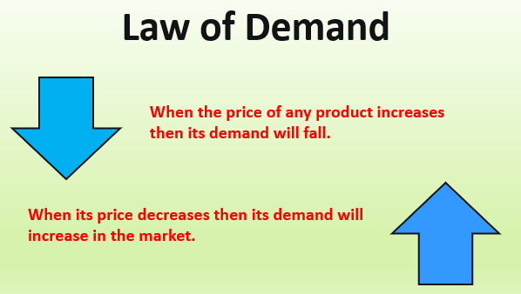

The relationship between demand and price is known as the **demand schedule**

**--**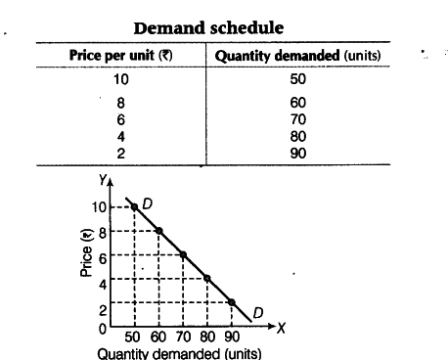

From the graph above

* More products are demanded when the product falls. For example, only 50 products are bought when the price is K10.00, but at K2.00, 90 products are b-ought.
* The quantity of products bought is maximum when the price is lowest.
* When the curve cuts the vertical axis, the quantity demanded is zero and nobody is willing to buy at that price.
* When the curve cuts the horizontal axis, the price is zero. This indicates the excess quantity that could be given free without paying.
* The demand curves rises from right to left. This is illustrated by the diagram below.

-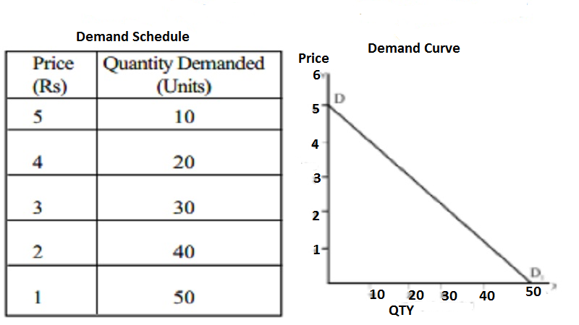

**FACTORS THAT INFLUENCE DEMAND FOR GOODS IN MALAWI.**

1. **Price of the product**

-An increase in price of the commodity, ceteris paribus, will lead to reduction in the number of people buying the product while a reduction in the price will lead to increase in number of people purchasing the product.

1. **Price of related goods or services.**

An increase in prices of maize’s substitutes such as rice will lead to increase in demand for maize and vice versa.

1. **Income levels of consumers**

-An increase in household income will lead to increase in demand for maize if maize is a normal product.

1. **Population size**

When the population size increases, the demand of consumer’s income will cause an increase in demand for normal and luxury commodities due to an increase in purchasing power.

1. **Tastes and preferences of the consumers**

If the taste or preferences for the commodity increases, then there will be increase in demand for the commodity.

1. **Government policy**

-Government may impose tax on certain goods leading to increases in prices and this is likely to decrease the demand. However, government may subsidise -the price of certain goods which increases demand for such goods.

1. **Advertisement**

It creates more awareness of commodity existence in the market; hence, c-onsumers will tend to demand more of that particular commodity.

1. **Price expectations**

If there is a speculation of a decrease in price of certain commodities, the tendency of the consumers is to stop buying those commodities until their -prices fall, thus lowering their demand. However, when speculation is about an increase in the prices, consumers will buy in large quantities before the prices increase.

**DESCRIBE THE RELATIONSHIP BETWEEN SUPPLY AND PRICE**

The law of supply states that “as the price of goods or services increases, the corresponding quantity of goods or services offered for sale increases and vice versa”.

The relationship between supply and price is referred to as the **“supply schedule”.**

Wh-en the supply schedule is represented graphically, a supply curve is obtained.

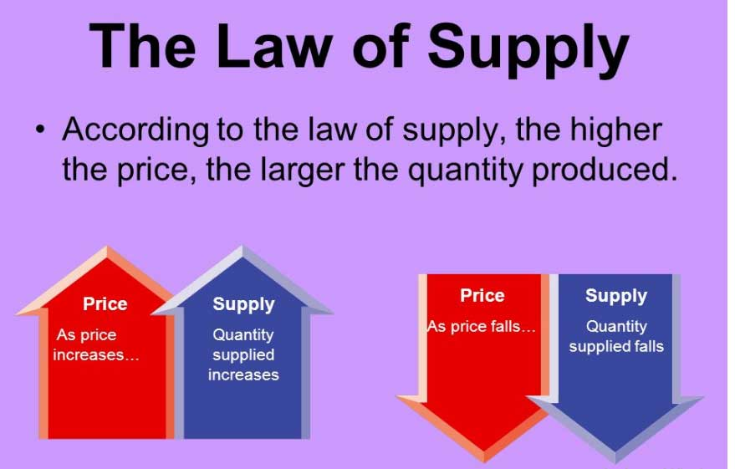

**EXAMPLE**

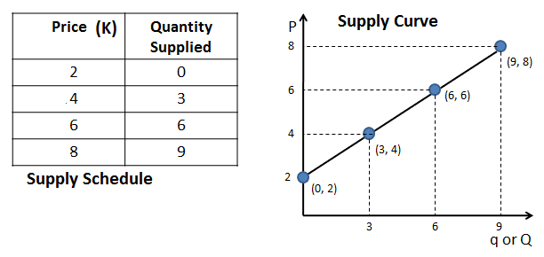

**From the graph**

* Suppliers bring more goods to the market when the price is high.
* As the pice increases, the quantity of commodities supplied increases.
* The supply curve rises from the left to right.

**Factors other than price that would influence supply of product**

1. **-Price of factors of production**

An increase in the price of factors of production, such as raw materials and labour, will lead to the production of that product less profitable. This will lead to a fall in the supply (a shift in the supply curve).

1. **Change in state of technology**

-This would influence the supply in that if there was an improvement in technology used to produce a product, it would lead to an increase in profitability of that product and, therefore, more would be supplied.

1. **Price of commodity or related goods**

An increase in the price of a product would lead to the increase in the supply of its complementary product.

1. **A change -in weather**

It- would affect the supply of products either positively or negatively. For instance, drought might lead to a decrease in maize production.

1. **Price expectation**

-When the sellers suspect that the price of a commodity will increase, they will supply less awaiting the price to rise. If the price of the commodity is expected to fall, more of that commodity will, be supplied for sale before the prices falls

1. **Government policy**

Government imposition of tax on a commodity raises its costs of production. But when the government provides subsidies on the productivity or commodity, more farmers will be willing to produce that particular commodity hence its supply increases.

1. **Number of sellers**

When the sellers dealing with the same products increases, the supply of the products will increase.

**HOW MARKETING FORCES (DEMAND AND SUPPLY) DETERMINE PRICE OF C-OMMODITIES**

* **Price determinants** refer to how demand and supply interact to determine the price of commodities.
* Producers influence the supply whereas consumers influence the demand of -a commodity.
* When demand is high on the market and the supply of commodities is low, the price increases.
* Demand and supply influence the price of a commodity in a given market at a particular time.
* When the amount of supply is high and the demand for the commodities is low, the price falls or drops. In this situation, the seller reduces the price so that she/he can sell out all their commodities.
* -Producers are normally prepared to sell the largest quantity of a product -when the price is at its highest. Consumers on the other hand are willing and able to buy the highest quantity when the price is at its lowest.
* The price of a commodity is determined by the interaction of supply and demand in a market.

**EQUILIBRIUM PRICE AND EQUILIBRIUM QUANTITY**

* **Equilibrium Price** is the price when the quantity demanded is equal to the quantity supplied while **Equilibrium Quantity** is the quantity at the **Equilibrium Point**
* **Equilibrium Point** is the point where the quantity demanded by consumers is equal to the quantity supplied by the suppliers or sellers at the market place.
* In other words, at **Equilibrium Point**, the quantity of a good supplied by producers or sellers equals the quantity demanded by consumers.
* The graph below illustrates the position of Equilibrium Quantity, Equilibrium Price and Equilibrium Point.

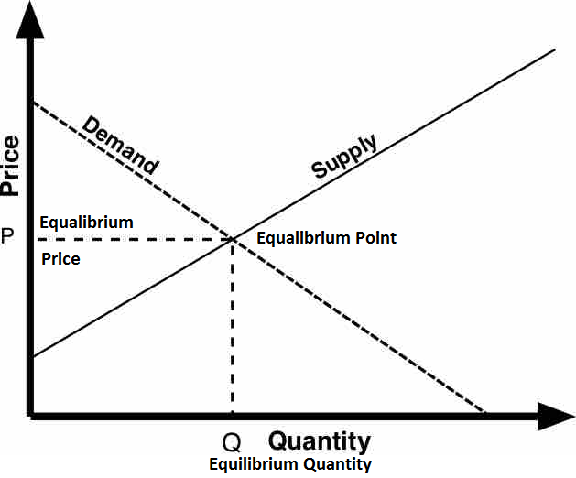

**TABLE SHOWING QTY DEMANDED AND SUPPLIED IN KILOGRAMS AND THEIR PRICE**

|  |  |  |
| --- | --- | --- |
| **PRICE PER KG(MK)** | **QUANTITY DEMANDED** | **QUANTITY SUPPLIED** |
| 320 | 200 | 1000 |
| --280 | 300 | 900 |
| 240 | 400 | 800 |
| 200 | 500 | 700 |
| 180 | 600 | 600 |
| 140 | 700 | 500 |
| 100 | 800 | 400 |
| -60 | 900 | 300 |
| 40 | 1000 | 200 |
| 20 | 1100 | 100 |

From the schedule above, the **Equilibrium price** is **K180**. At this point, the quantity supplied and the quantity demanded is **600kg.** This is called the **Equilibrium Quantity.**

* A rise in price would change both the quantity supplied or demanded.
* When the schedule is represented graphically, the demand curve and the supply curve intersect at some point. The point of intersection of the normal demand and normal supply curves is the **Equilibrium Point**. This is shown in the graph below

**GRAPH SHOWING DEMAND AND SUPPLY IN PRICE DETERMINATION**

**-**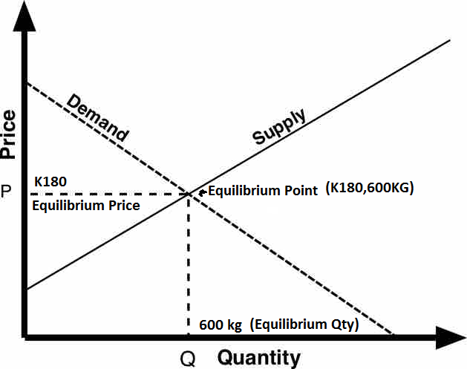

**MARKETING AND MARKETING FUNCTIONS**

* **Marketing** is defined as “all the processes involved in the transformation and flow of goods and services from the farm to the consumer”
* Marketing functions refers to the processes involved in marketing.

**CATEG-ORIES OF MARKETING FUNCTIONS**

* The three categories of marketing include

1. Exchange functions
2. Physical l functions
3. -Facilitating functions

**EXCHANGE FUNCTIONS OF MARKETING**

The following are the exchange functions of marketing

1. **Buying**

This is done by traders who buy agricultural produce either in small quantities or in large quantities from farmers and store in warehouses for sale later on.

1. **Selling**

Selling refers to the activities that assist in presentation of the product to the consumer for eventual buying. It involves bargaining for better prices and

**PHYSICAL FUNCTIONS OF MARKETING**

The following are the physical functions of marketing:

1. **Transportation and distribution**

* Prod-ucts are carried from buying centres to the factory for processing, and to the consumers, to the wholesalers or retailers.
* Distribution ensures get the produce at the right time and within easy reach.

1. **Packing**

* Packing refers to putting produce in containers such as sacks, crates ,boxesor baskets
* The main of packing is

1. To facilitate transportation of produce.
2. To protect the produce against damage and bad weather condition
3. To- prevent theft and adulteration
4. **Storage**

* It ensures availability of the produce between harvest seasons
* It protects the produce against damage by pests and from deterioration due to bad weather
* It allows agro-based industries to get raw materials throughout the year or throughout the manufacturing period.

1. **Processing**

* It refers to changing the state of a product into a more acceptable or usable form. Examples include:

1. Wheat is ground into flour
2. Raw milk is changed into powder milk, yoghurt or cheese.
3. Hides and skin are changed into leather.

* It also increases the shelf life of most produce.
* It allows consumers to choose a wide variety of forms for certain produce e.g. fresh meat or canned meat.

1. **Grading and standardization**

* Grading refers to sorting the produce in terms of quality according to various market standards**.**
* It makes it easy to assign a price tag to the produce depending on its quality
* It enables consumers to buy the quality they prefer

1. **Assembling**

* It refers to collection or gathering of goods from different places to a common place.
* It facilitates easier transportation, grading and cover cost of transportation.

1. **Displaying**

* It involves arranging agricultural produce in attractive patterns conspicuously to easily attract the potential buyer.

1. **Packaging**

* It is the- wrapping of the produce with the materials in which it is finally presented to the consumers to buy**.**
* It is important because

1. It eases transportation of a product
2. It makes the product presentable to consumers
3. It keeps the product safe from any contamination**.**

**FACILITATING FUNCTIONS OF MARKETING**

The following are the facilitating functions of marketing

1. **Financing**

* This involves the provision of capital to finance all the market functions right from the purchase of raw materials to the final sale of the finished goods.

1. **Collection and analysis of market information(market intelligence/market research)**

* This involves gathering information on the market situation for particular products which aids in price determination, where and when to sell or buy.

1. **Advertisement**

* It is the -art of informing, stimulating and educating the consumer on the particular product.
* The main aim of advertising is to persuade the consumer to buy the product at the expense of competing products.

1. **Risk bearing**

* It involves the marketing agency to be ready for unforeseen happenings which can occur in the course of marketing. This can be done by insuring the produce against the risks.

**PROBLEMS ASSOCIATED WITH AGRICULTURAL MARKETING**

The problems and their possible solutions include

1. **Seasonality**

* Supply -of the produce is dependent on seasons which create a problem of surplus and shortage of produce. This in turn causes the problem of price fluctuation.

**Solution-**

Famers- should invest in irrigation agriculture to ensure that crops are produced throughout the year including the dry season

1. **Perishability**

* Some agricultural produce easily go bad or spoiled and hence lose quality rapidly.
* Examples of perishable products include fruits, vegetables, eggs, meat and milk and they need to reach the market quickly before spoiling.

**Solution**

1. The farmer should use cold stores and refrigerated transport vehicles.
2. The farmer should also process the produce such as canning of fruits, dehydration of vegetables and pasteurization of milk.
3. Improvement of transport system which will help the produce fast enough to reach the market.
4. **Storage**

* Agricultural products need to be stored when surplus to ensure their continuous supply during times of deficit. This requires construction of expensive storage facilities hence increasing marketing costs.
* Poor storage causes problem of product spoilage.

**Solutions**

1. The government should facilitate construction of communal grain handling silos and bins.
2. Providing cold stores to handle perishable products to protect them from spoilage.
3. **Price fluctuations**

* -When the produce is in high supply, prices tend to be low and the vice versa which tend to frustrate the producer**.**

**Solution**

* There is need to improve storage facilities to ensure product supply throughout the year. This will help price stabilization.
* Farmers should also have price contracting to avid fetching low prices during times of high supply.

1. **Bulkiness**

* Heavy and voluminous agricultural products are expensive to transport and store. This increases the cost of marketing.

**Solution**

* There is need to develop efficient transport system such as rail transport, good roads and ports to handle bulk goods at reasonable costs.

1. **Poor transport and communication**

* Production- of agricultural produce is done in the rural areas which tend to have poor transport and communication system. This increases the costs and m-akes farmers unable to access markets.

**Solution**

* Improvement of roads, rails, sea ports and airports to enable the produce to reach the market on time.
* Making modern communication accessible to the producers to access market information.

1. **Low state of knowledge**

* Farmers are ignorant of the market conditions since most of them are not highly educated.

**Solution**

* Encouraging farmers to join cooperatives to benefit from organized marketing.
* Educating farmers on price theories
* Improving communication infrastructures such as optic fibre cable to make farmers to easily access internet information.

1. **Change in -market demand**

* Changes in consumer taste or price of related substitute products affect the market demand. This makes the producer to lose their market and hence forcing them to sell their produce at low prices.

**Solution**

* Price contracting with potential buyers will help producers to secure their market at a good price.

1. **Change in market supply**

* There are price fluctuations due to deficit and surplus of produce based on seasons**.**

**Solution**

* Price contracting with potential buyers will help producers to secure their market at a good price.

**NB:** Other problems associated with agricultural marketing include Limited elasticity of demand; agricultural commodities are subject to international quality control and discovery and influx of synthetic products into the market**.**

**CHAPTER 6: AGRO-BASED INDUSTRIES IN MALAWI**

Agro-based industries refers to the firms that either process agricultural raw materials into finished goods or those manufacturing agricultural inputs like seeds, fertilizers, equipments or tools.

**CATEGORIES OF AGRO-BASED INDUSTRIES**

**Agro-based industries are divided into**

1. **PRIMARY INDUSTRIES**

* These are agro-based industries that produce primary products or raw materials.
* Their products are sent to the factory for processing.
* -The-y are named based on the product that they produce such as Coffee, Tobacco, Dairy and Poultry Industries.

1. **SECONDARY/MANUFACTURING INDUSTRIES**

* These are agro-based industries which are involved in processing of raw materials or primary products from primary industries into finished goods for consumption.
* They can be broadly categorized as textile, food and beverage, chemical and machine industries.
* The two main categories of manufacturing industries in Malawi are

1. Agroprocessing industries
2. Industrial goods manufacturers

**AGROPROCESSING INDUSTRIES IN MALAWI**

Agro processing industries are industries that convert raw materials into finished goods for consumption or as intermediate products for manufacture of other final products.

Examples of Agrobased industries under Agroprocessing industries include

1. **COTT-ON GINNING INDUSTRIES**

* These agro based industries process raw cotton into lint and cotton seed.
* Cotton seeds are processed into oil for human use and seed cake used in making animal feeds.
* Cotton lint is used in textile industries.
* Examples of ginners in Malawi include

1. Clark Cotton Malawi
2. Great Lakes Cotton Company.
3. **MILK PROCESSING INDUSTRIES**

* These Agrobased industries process raw milk into various products for consumption.
* Examples of products processed from raw milk include

1. Cheese
2. Ghee
3. Cream
4. Butter
5. Ice Creams
6. Yoghurt
7. Whole milk
8. Skim milk
9. Powder milk

Examples of Milk Processing Industries in Malawi include

1. Dairy Board Malawi Limited in Blantyre and Lilongwe
2. Sun Crest Creameries Industries
3. Lilongwe Dairy Industries
4. **F-RUIT PROCESSING INDUSTRIES-**

* These agro-based industries convert raw fruits into concentrates used to make fruit juices, jams among others.
* These agro-based industries are also involved in canning of fruits.
* Examples of Fruit Processing Industries include the following

1. Dairy Board Malawi Limited
2. Mulanje Peak Foods which is located at Mulanje district near Blantyre
3. **VEGETABLE OIL PROCESSING INDUSTRIES**

* These agro-based industries are involved in extraction and refining of vegetable oils from oil seeds such as cotton seed and sun flower.
* Examples of Vegetable Oil Processing Industries include:

1. Capital Oil Refining Industries Limited at Chilimba in Blantyre
2. Kamwendo Cooking Oil Co-operative Society.
3. **MEAT PROCESSING INDUSTRIES**

* These are agro-based industries which are involved in meat processing and canning.
* Examples of Meat Processing Industries include

1. Nyasa Food Processing Machinery
2. Orimeat Products Limited
3. Lilongwe Cold Storage Company Limited- This processes meat as well as skin and hides.
4. **TOBACCO PROCESSING INDUSTRIES**

* These are agro-based industries which process tobacco leaves from the farmers.
* An example is Alliance One Tobacco (Malawi) Limited located in Lilongwe.

1. **TEA PROCESSING INDUSTRIES**

* These agro-based industries process tea leaves.
* Examples of Tea Processing Industries include

1. Tea and Coffee Merchants Association of Malawi Limited located in Lilongwe
2. Lujeri Tea Estates
3. Likabula Tea factory
4. **COFFEE PROCESSING INDUSTRIES**

* These process coffee in Malawi
* An example of Coffee Processing Industries include

1. Mzuzu Coffee Co-operative Society.
2. Malawi Tea Factory Company
3. **FLO-UR INDUSTRIES**

* These are grain milling companies which convert maize grains into flour.
* Examples of the Flour Industries include

1. Bakhressa Grain Milling Malawi-i Limited
2. Alpha Milling Company.

**SPECIFIC AGRO-BASED INDUSTRIES THAT PROCESS RAW MATERIALS INTO SECONDARY PRODUCTS**

1. **Bakhressa Grain and Milling Company**

* It processes Wheat and Maize into products such as Maize flour and Wheat Flour.

1. **Malawi Dairy Industry**

* It processes Milk into Fresh Milk, Yoghurt, Chambiko, Butter, Ghee and other milk products

1. **Chibuku Products Limited**

* It processes maize into Chibuku beer

1. **David White Head and Sons (Mapeto wholesalers) Limited**

* It processes cotton into cotton lint and textiles, cotton seeds

1. **Illovo Sugar Company**

* It produces sugar cane into sugar

1. **Lever Brothers**

* It processes Cotton Seed, Sunflower into Cooking Oils
* It processes groundnuts into Peanut Butter and Stock margarine

1. **Tambala Food Products Division**

* It processes Tea Leaves into Chombe Tea
* It processes Groundnuts into Tambala groundnuts and Superstar Cooking Oils

1. **Cooking Oil Refineries Limited (CORI)**

* It processes Sunflower and groundnuts into Kukoma Cooking Oils.
* It processes Meat into Sausages

1. **Rab Processor Limited**

* It processes Rice and groundnuts into Super Faya Rice.
* It processes Maize into Snow White -Ufa Oyera

1. **BAT(Malawi) Limited**

* It processes Tobacco Leaf into cigarettes.

**MANUFACTURERS OF INDUSTRIAL GOODS/INPUTS**

* These consist of agro-based industries that produce products that are inputs used on the farm.
* Examples of Agro-based Manufacturing industries include

1. **Garment and Textile Industry**

* This industry uses cotton lint from ginners to form yam which is used to make cloth.
* An example of Garment and Textile industry is Mapeto Company which has replaced David Whitehead and Sons..

1. **Light Engineering Industry**

* This industry is involved in production of tools, equipment and machineries which- are used on the farm.

1. **Light Chemical Industry**

* This industry is involved in fertiliser, pesticides, fungicides and herbicides formulation and production**.**
* **Examples include**

1. Medlab Malawi Limited
2. OPTICHEM Limited etc.

**EXAMPLES OF AGRO-BASED INDUSTRY THAT MANUFACTURE INPUTS**

1. **Agrimal (MW) Limited**

* It manufactures agricultural tools such as animal drawn ridgers, ploughs, cultivators and hand operated tobacco presses, hoes and pangas.

1. **OPTICHEM (2000) Limited**

* It manufactures Compound NPK Fertilisers
* It is a direct importer of straight fertilsers like Urea, CAN and Ammonia Phosphates.

1. **Pannar Seed MW Limited-**

* It is a producer and supplier of hybrid maize seed and performance tested vegetable seeds.

1. **PIPECO (Pipe Irrigation Pump Engineering Company)**

* It is the manufacturer of irrigation pipes, hose pipes, borehole pumps and spare parts.

1. **Agro-Sack Industries**

* It manufactures polypropylene bags for seeds, fertilizers, and rice.

1. **Charles Stewart Old Day Chicks**

* It is the distributor of hyline layers and Ross broilers chicks.

1. **Rab Processors Limited**

* It is a supplier of livestock feeds such as growers mash, layers mash, broilers starter and finisher.

**ROLES OF AGRO-BASED INDU-STRIES IN SUPPORTING THE GROWING POPULATION**

1. **Equipping farmers with inputs**

* They provide farmers with farm inputs such as fertilizers, improved seeds, livestock feeds, breeds and machinery. These help farmers to increase agricultural production which in turn help to increase income for farmers**.**

1. **Processing raw materials**

They process raw materials to a form desired by consumers.

1. **Providing market for agricultural products**

They buy raw materials from the farmers thereby forming readily available markets for the farmers’ products**.**

1. **Feeding and clothing the nation**

* Some agro-based industries such as Grain and Milling Company, NALI, CORI, -Rab Processors Limited process food which is distributed to all parts of the country to feed the growing population.

1. **Providing employment**

* The agro-based industries employ many people who in return receive an income that helps to support the families.

1. **Boosting the foreign exchange**

* Agro-based industries export their processed products to earn foreign countries in order to earn foreign exchange.

1. **Enhancing international relations**

The involvement of agro-based industries helps the country to engage in international trade of bilateral or multilateral in nature.

**CHAPTER 7: FOOD DISTRIBUTION**

**FOOD SECURITY**

* Food security is defined as when all people have physical, social and economic access to sufficient, safe and nutritious food.
* Food security can also be defined as “ accessibility of people to adequate , -balance-d , affordable, socially acceptable and safe food”
* In Malawi, food security is defined in terms of people’s access to maize which is the main stable food. This means that food insecurity may exist if maize supply is below the minimum required levels despite high production of other food crops.

**COMPONENTS OF FOOD SECURITY ACCORDING TO WHO**

The following are the four components of food security according to World Health Organisation**:**

1. **Availability**

-This means that food should be provided in sufficient or adequate amounts to meet people need.

1. **Accessibility**

This means that people should have both physical and economical means to obtain food.

1. **Adequacy**

This means that the available food should be nutritious and safe for healthy lifestyles. The food should be provided in an environmentally sustainable way.

1. **Acceptability**

This means that the available food should be culturally accepted.

**FOOD FOR SELF SUFFICIENCY**

Food for self sufficiency refers to the ability of a country to internally produce food that is adequate to meet dietary requirements for its population without importation.

**WHY IT IS DIFFICULT TO ACHIEVE FOOD SECURITY & FOOD FOR SELF SUFFICIENCY?**

1. This is due to crop failure due to drought, pests and diseases outbreaks, frosts, h-ailstorms among other natural catastrophes.
2. Internal security due to war, civil conflict and political insecurity which leads to reduced production.
3. Lack of economic means that is inadequate resources such as capital to engage in increased production.

**WHAT ARE THE KEY FACTORS IN FOOD DISTRIBUTION**?

1. Transport and communication infrastructure. This means that to move food, there must be sufficient means to facilitate the movement of food. These include adequate and good roads, railways, airports and seaports.
2. Food handling technology and regulation such as refrigeration, drying and storage. Food must be properly treated to ensure it does not spoil when in store or on transit.
3. Adequate source and supply logistics information must be available on where there is demand or need and where food can be sourced.

**WHAT ARE THE KEY FACTORS THAT NECESSITATE FOOD DISTRIBUTION?**

1. Some areas in the country experience a surplus food while others experience a deficit in production owing to seasonal differences. This calls for supply of food to deficit areas.
2. Natural disasters such as flooding, pest and disease attack on crops and livestock in other areas. This necessitates moving food s to disaster areas.
3. Occurrence of vulnerable households due to acute poverty, family affected and infected with HIV and AIDS need to be supported with food.
4. School feeding programs.
5. Feeding of refugees.
6. Need to cater special groups that need supplementary feeding such as expectant mothers, breastfeeding mothers and malnourished children under 5 years among others.

**IDENTIFY THE FOOD DISTRIBUTION AGENTS IN MALAWI.**

These include

1. **Household**

* As a producing unit the farmer and his family take their produce to the market for sale through retail outlets.

1. **Marketing agencies**

* -They are individuals or organizations that are involved in buying food either in bulk or in small quantities, transport to needy areas and later sell to people for consumption.
* These include

1. Producers
2. Wholesalers
3. Middlemen
4. Retailers
5. Co-operative
6. **Government of Malawi and Malawi Government Agencies.**

* They are involved in transporting food to emergency prone areas as a result of flooding, drought or political instability among others.

1. **Non-Government Organizations(NGOs)**

* These are involved in food distribution to special groups such as refugees; hunger stricken people; HIV and AIDS infected and affected people, flood victims, internally displaced persons.
* These NGOs include

1. World Food Programme
2. United Nations High Commission for Refugees-UNHCR
3. -Religious based organizations such as Catholic Relief Services

**WHAT ARE THE ROLES OF FOOD STORAGE IN ENSURING FOOD SECURITY?**

1. It ensures that surplus food is stored for future use during times of deficit.
2. It ensures that food is protected from spoilage or deterioration of quality from pests and diseases attack.
3. It regulates food supply
4. It helps to stabilize prices of food Stable prices ensure food is accessible to all people.

**DESCRIBE THE FACTORS THAT MAY HINDER THE ACHIEVEMENT OF FOOD SECURITY AND SELF-SUFFICIENCY**.

1. The rapid population growth which results in high Malawi population increases food insecurity. The high population exerts pressure on the scarse production resources.
2. The -large family size in Malawi which does not engaged in farming activities.
3. Large family size requires more food for its members and makes less money invested in farming.

**CHAPTER 8:** **ESSENTIAL PLANT NUTRIENTS**

**A plant nutrient** is a mineral element needed by a plant to grow and complete its life cycle.

**Essential plant nutrients** are chemical elements required by plants for optional growth and development. They are also known as **essential elements**

**WHAT ARE THREE CONDITIONS TO BE SATISFIED FOR A PLANT NUTRIENT TO BE ESSENTIAL?**

For a plant nutrient to be essential, it must satisfy the following three conditions:

* The nutrient must be directly involved in metabolic processes in plants.
* Its deficiency must cause specific deficiency symptoms in plants.
* The deficiency symptoms can be corrected only by supplying (lie plant with that nutrient

**IMPORTANCE OF ESSENTIAL PLANT ELEMENTS**

1. They- are important in plant metabolism
2. In their absence, the plants have abnormal growth and development.
3. Each nutrient has a role it plays in plant growth and cannot be replaced by another.

**MACRONUTRIENTS/MAJOR**

* These are chemical elements required by plants in large quantities for proper growth.
* The examples of major nutrients include the following

|  |  |
| --- | --- |
| **Macronutrients/Major nutrients** | **Source** |
| Carbon | Atmosphere |
| Hydrogen | Atmosphere |
| Oxygen | Atmosphere |
| -Nitrogen | Soil |
| Phosphorus | Soil |
| Potassium | Soil |
| Magnesium | Soil |
| Calcium | Soil |
| Sulphur | Soil |

-The two groups of Macronutrients include

**PRIMARY NUTRIENTS**

These primary nutrients include nitrogen, phosphorus and potassium. They are required in higher amounts as compared to the secondary nutrients.

**SECONDARY NUTRIENTS**

These include carbon, hydrogen, oxygen, magnesium, calcium and sulphur. They are required in lower amounts as compared to the primary nutrients.

**MICRONUTRIENTS/MINOR NUTRIENTS/TRACE ELEMENTS**

* These are chemical elements required by plants in smaller quantities for normal growth.
* Examples of trace elements include the following

1. Manganese
2. Zinc
3. Copper
4. Iron
5. Molybdenum
6. Cobalt
7. Boron
8. Chlorine

**SOURCES OF ESSENTIAL PLANT NUTRIENTS**

1. Decayed organic matter from plant nutrients on decomposition and -mineralization.
2. Organic manures which include green manure, farm yard manure and compost manure.
3. Inorganic fertilizers which supply one or more plant nutrients, they are applied either in the soil directly or on leaves as foliar sprays.
4. Soil amendments such as lime application which provides calcium and magnesium.
5. Rain water dissolved with some elements for example sulphur dioxide may dissolve in water to form acid rain that supplies sulphur into the soil.
6. Biochemical fixation as in nitrogen by Rhizobium bacteria in leguminous -plants and also by free-living bacteria such as **clostridium** and **azotobacte**r.

**ROLE OF ESSENTIAL PLANT NUTRENTS IN PLANT GROWTH AND CROP PRODUCTION**

1. They take part in enzymatic reactions.
2. They are structural components of the plant cell.
3. They are constituents of cell metabolism compounds
4. They are important in energy transformation reactions in the cell.

**EXAMPLES OF MACRONUTRIENTS, THEIR SOURCES, ROLES AND DEFICIENCY SYMPTOMS**

1. **Nitrogen**

Nitrogen is absorbed by plants as nitrate ions (NO3) or as ammonium -ions (NH4)

**Functions**

* For deep green colour (chlorophyll)
* Major component of proteins
* Increases leaf area and vegetative growth in crops
* Regulates the a availability and utilization of phosphorous and potassium
* Makes plants and their fruits succulent e.g. in cabbage, carrots lettuce, melons
* Increases grain yield by increasing grain size in both cereals and grain legumes

**Source**

* Atmosphere and soil

**Deficiency Signs**

* Leaves lose chlorophyll (chlorosis) and become yellow (starts at the leaf tips of the lower leaves and spreads a long the mid-rib until the entire leaf is yellow. Later the lower leaves may become brown or die.
* S-low plant growth, which results in stunted plants (dwarfism)
* Premature leaf fall

1. **Phosphorous**

* Absorbed as H2PO4 especially at lower pH and HPO43- at higher pH values. The dehydrogenated phosphate form is better absorbed.

**Functions**

* + - * Increase root development, especially of secondary roots
      * Strengthens straw of cereal crops, so lodging is reduced.
      * Speeds up the maturity of crops by stimulating flowering and seed formation.
      * Improves the quality of fruits, vegetables, forages and cereal crops
      * Increases disease resistance
      * It is a component of Adenosine Triphosphate (ATP), Adenosine Diphosphate (ADP) and Adenosine Monophosphate (AMP) (which are important in photosynthesis and various metabolic processes, such as carbohydrate metabolism, amino acid metabolism, fat metabolism etc)
      * Is -a component of nucleic acids, which makes it essential for reproduction and seed.

**Sources**

* From the soil

**Deficiency Signs**

* Reduce root development especially of secondary roots
* Leaves have purplish colour
* Slow and stun-ted growth
* Poor branching, since lateral buds remain dormant
* Dead spots on leaves and fruits and fruits
* Fewer and smaller tubers
* Delayed maturity
* Poor development of seeds, grains or fruits

1. **Potassium**

Absorbed in the form of potassium ions (K+)

**Functions**

* Strengthens cellulose in cell walls to make systems strong and reduce stem lodging .
* Facilitates the translocation of sugars from leaves to other plant parts, especially tubers or seeds, so that they are well - filled (plump)
* Necessary in formation of starch and proteins
* Increases disease resistance such-as powdery mildew and root rot
* Acts as catalyst to activate enzymes necessary in metabolic processes (e.g. nitrogen metabolism. photosynthesis, respiration etc)
* Promotes the growth of meristematic tissue
* Regulates the opening and closing of the stomata by controlling the water content of plant cells (cell turgidity)
* Improves the qualities of crops e.g. fruits and vegetables

**Sources**

* Fro-m the soil

**Deficiency signs-**

* Scorching of the leaf edges (burnt leaf margins from tips spreading backwards beginning with lower leaves)
* Weak stalks, resulting in high plant lodging (stalk breakage)
* Small fruits, seeds and tubers
* Small dots appearing on leaves

1. **Calcium**

* Absorbed as calcium ions (Ca2+)

**Functions**

* For cell division (mitosis) so that elongation can take place in apical tips of the root system and shoot system
* Raise soil pH, which increases the availability of phosphorous and potassium, and- the multiplication of nitrifying bacteria Is a component of cell wall structure Is useful in protein synthesis

**Sources**

* From the soil

**Deficiency Symptoms**

* Terminals buds and root tips fail to grow so that plant stops growing (it remains a dwarf)
* In maize the funnel (new leaves are rolled up) rnay fail to grow-Old or even emerge
* Terminal buds -(growing points) die
* Premature Shedding of flowers and buds
* Weak stems

1. **Magnesium**

* Absorbed as Mg2+ ions

**Functions**

* Is a component of chlorophyll molecule
* Activates enzymes in the metabolism of carbohydrates and nitrogen
* Increases the oil content in g/nuts and soya beans

**Sources**

* From the soil

**Deficiency Signs**

* -Interveinal chlorosis on leaves where veins remain green while the rest of the leaf is yellow
* In some crops, like cotton lower leaves develop a reddish purple colour

1. **Sulphur**

* Is absorbed by plants as sulphate (SO42 )ions 20

**Functions**

* Increases the oil contents of oil crops such as sunflower, groundnuts and soya beans-
* I-s a constituent of three amino acids: cystine , cysteine and thiamine
* Activates some proteolytic enzymes, such as papain
* Is useful in Nodule formation on legume roots for nitrogen fixation
* Is needed in protein synthesis and improves the biological value of proteins

**Sources**

* From the soil as organic sulphates in organic form as gypsum

**Deficiency Symptoms**

* Leaves turn light green (sometimes yellowish) starting with young leaves
* Small and short plants with thin (spindly) stems
* Reduced modulation in legumes

**EXAMPLES OF MICRONUTRIENTS/TRACE ELEMENTS**

1. **Iron**

* Is absorbed by plant roots as ferrous (Fe2+ )iron or ferric (Fe3+) ions

**Functions**

* Necessary for the formation of chlorophyll
* Activities various respiratory

**Sources**

* Inorganic enriched NPK fertilizers and chelates
* Organic matter

**Deficiency signs**

* Interveinal chlorosis of young leaves
* Young -leaves can turn completely white in severe cases
* Twigs stop growing and die (the whole branch may die in severe cases

1. **Boron**

* Is absorbed mostly as borate (BO3) ions

**Functions**

* Essential for cell division in meristematic tissue
* Regulates carbohydrate metabolism
* Important in the transfer (translocation ) of sugars (starch) within the plant

**Sources**

* Inorganic enriched NPK fertilizer and borax
* Organic matter

**Deficiency signs**

* Poor growth and sometimes terminal buds die
* Shorting- of internodes
* Poor grain tilling on maize cobs
* Soft or necrotic spots on fruits or tubers

1. **Manganese**

* Is absorbed as Mn2+ ions

**Function**

* Activates enzymes and acts as catalyst in the formation of chlorophyll

**Sources**

* Fertilisers -rich in manganese sulphate.
* Organic matter

**Deficiency signs**

* Mottled interveinal chlorosis of young leaves
* Interveinal white / brown specks in some cereals

1. **Molybdenum**

* Is absorbed as molybdate (Mo O42- ) ions

**Functions**

* Promotes symbiotic nitrogen fixation in legumes
* Increases nitrogen utilization

**Source-s-**

* Enriched inorganic NPK fertilizers
* Organic matter

**Deficiency signs**

* Whip tail in brassica crops such as cauli flower and broccoli (leaves curl into a whip like tail)
* Failure of legume (in severe cases)

**NB:** Other trace elements include Copper, cobalt, sodium, zinc and chlorine.

**HOW ESSENTIAL PLANT NUTRIENTS ARE DEPLETED FROM THE SOIL**

1. **Soil erosion**

This involves removal and carrying away of the top fertile soil by water or wind. This removal leaves the soil infertile.

1. **Crop removal**

This involves cropping which results in large quantities of nutrients being removed from the soil by the crops which are later harvested**.**

1. **Leaching**

This -means the dissolved minerals (nitrogen, sulphur, magnesium and potassium) are carried to the lower horizons beyond the reach of plant roots.

1. **Volatilization**

This involves conversion of nutrient into a gaseous form which escapes into the atmosphere when they are exposed to heat from the sun or from burning. Examples of these nutrients lost in this way are nitrogen and sulphur. Nitrogen is converted into nitrogen gas and nitrogen dioxide gas while sulphur is converted into sulphur dioxide and hydrogen sulphide gas.

1. **Fixation**

It is a process that makes nutrients unavailable to plants through formation of insoluble compounds in the soil. For example soluble phosphate ions combine with iron and aluminum to form insoluble compounds.

1. **Removal by weeds**

Weed-s remove substantial amount of nutrients from the soil.

1. **Change in soil pH and salinisaton**

Soil pH affects availability of nutrients to plants. At low pH, phosphorus is fixed into aluminum or iron compounds which are insoluble and unavailable to plants. Low pH (acidic soils) affects activity of soil microorganisms. For example, nitrogen fixation by Rhizobium bacteria is reduced.

1. **Burning of vegetation**

Burning destroys plant nutrients through volatilization. Accumulation of as from burning raises soil Ph which affects availability of certain nutrients. As may also increase certain nutrients toxic levels. For example, ash increases potassium ions which make magnesium unavailable.

Burning destroy decomposers in the soil reducing decomposition and mineralization.

1. **Immobilization**

This involves conversion of an element from inorganic to organic form which is unavailable to plants. This process is controlled by microorganisms. For example, soil nitrates are converted to nitrogen gas and nitrous oxide and under warm anaerobic conditions. Pseudomonas bacteria are an example of denitrifying bacteria.

**ORGANIC MANURES**

* These are substances that are prepared from animal and plant remains and are added to the soil to supply plant nutrients on decomposition and mineralization.
* Organic manure includes green manure, farm yard manure and compost manure.

**COMPOST MANURE**

**WHAT IS COMPOST MANURE? EXPLAIN HOW IS IT PREPARED.**

* Compost manure is manure that is prepared from organic materials like soft hedge cuttings, grass, and kitchen wastes.

**Preparation**

* Compost manure is prepared by piling plant residues in a heap or a pit. The -material should be turned over at regular intervals to facilitate a uniform rate of decay.
* If the material is of low nitrogen content, ammonium sulphate may be added to improve the nitrogen content of the manure.
* If the material is dry, it can be moistened by sprinkling water.
* Protect the compost from direct sunlight and rain.

**FACTORS TO CONSIDER WHEN SELECTING A COMPOST PREPARATION SITE**

1. It must be a well drained area to avoid leaching of nutrients from the manure.
2. It must be near to plot of use in the farm to reduce labour and time wasted in the transportation of the ready compost manure to the farm.
3. Direction of the wind to prevent bad odours coming from the preparation site. Locate site on the leeward side of the main house.

**METHODS OF PREPARING COMPOST MANURE**

1. **INDORE/PIT METHOD**

This method is suitable for use in dry areas where moisture should be -conserved.

**HOW TO PREPARE COMPOST MANURE BY INDORE/PIT METHOD**

* Select a sheltered place with a cool shade to minimize evaporation near the field where the manure is to be used.
* Dig a pit with the dimensions 1.2m long, 1.2 m wide and 1.2m deep.
* Place the materials in the following sequence of layers
* Rough hedge cuttings/maize stalks to a depth of about 30 com to form foundation.
* A layer of grass, green weeds and kitchen wastes to a thickness of about 30cm.
* Add wood ash to neutalise the activity and phosphate fertilizers to -improve the phosphorous content of the manure.
* Sprinkle with water to initiate the decomposition process and regulate the temperature.
* Add a layer of top soil that contains micro organisms to help in the decomposition of the organic remains.
* Finally, a layer of soil is added to cover the pit and to prevent the escape of gases. To prevent loss of moisture, spread a layer of dry grass, add water, then cover the pit well with old iron sheets or polythene. The manure is usually ready after 3 to 6 months.

1. **FOUR HEAP SYSTEM/STACK METHOD**

* This system uses four heaps of materials containing crop residues, animal wastes, compost manure, inorganic fertilizers and top soil.

**THINGS TO AVOID WHEN MAKING COMPOST MANURE**

* Avoid using industrial wastes and town refuse when making compost because they may contain heavy metals in quantities which are toxic to plants and to human beings and to animals. They can human beings through food chain.
* Avoid use of non-biodegradable wastes such as polythene materials as they are not capable of being decomposed by bacteria or using other biological means.
* Avoid injurious objects such as nails, broken glass and metals.

**INORGANIC FERTILISERS**

* They are a source of concentrated form of macronutrients.
* Inorganic fertilizers are classified into straight fertilizers and compound fertilizers.

1. **Straight fertilizers**

These are fertilizers which contain only one of the three primary macro-nutrients.

Examples of straight fertilizers

1. Nitrogen (N)
2. Phosphorus(P)
3. Potassium (K).
4. **Compound fertilizers**

* These are fertilizers that contain two or three of the primary macro-nutrients.
* Incomplete compound fertilizers refer to the compound fertilizers that contain only two primary elements.
* Examples of compound fertilizers refer to the compound fertilizers that contain only two primary elements include Diamond Phosphate (DAP) that contains 18-47-0 AND 23;21:0
* Complete compound fertilizers refer to the fertilizer that contains all the three primary elements (N, P, K).
* Examples of Complete compound fertilizers refer to the fertilizer that contains all the three primary elements (N, P, K).

1. 20-10-10
2. 17-17-17
3. 15--15-15

2:18:15

**METHODS OF APPLICATION OF CHEMICAL FERTILIZERS AND ORGANIC MANURES**

**The methods include**

1. **BROADCASTING APPLICATION METHOD**

* This method involves scattering of fertilizer or manure over the soil surface to achieve a uniform spread.
* It can be done manually or by using a spreader.
* Manure or fertilizer can be left on the surface or can be incorporated into the soils by harrowing.
* It is highly applicable in paddy rice fields and in pastures

**Advantages**

1. Easy to apply hence less labourious.
2. Large amounts of fertilizer or manure can be applied within a short time.
3. It is the only applicable method of manure or fertilizer application in established pastures.

**Disadvantages**

1. Highly valuable fertilizer may lose nutrients unless incorporated into the soil.
2. Application of fertilizers or manure is effective when it is raining or irrigation should be done to move nutrients close to the root zone before volatilization takes place.
3. **BASAL APPLICATION/PLACEMENT/HOLE/HILL PLACEMENT METHOD**

* This method involves placing manure or fertilizer close to the seed during the planting process.
* Manure or fertilizer is placed in the planting hole or farrow and mixed with the soil before placing the seed.
* It is usually applicable to phosphatic fertilizers since the nutrient is less mobile and needs to be placed close to the root zone.

1. **TOP DRESSING METHOD/SIDE DRESSING METHOD**

* This method involves spreading of manure or fertilizers on the soil surface to the established crop in the field.
* By this method, fertilizers or manure is applied along the side of a crop row or around the plant.
* It is applicable in nitrogenous fertilizers application as it is readily soluble.
* Manure or compound fertilizers can be applied to pasture after cutting to stimulate regeneration growth.

1. **FERTIGATION METHOD**

* This method involves application of highly soluble fertilizer in irrigation water.
* The fertilizers are dissolved in water and applied through drip irrigation system or surface irrigation.
* It is a quick method of availing nutrients that are highly mobile.
* It is applicable in dry soils.
* Slurvy or liquid cow dung is diluted in irrigation water and applied through surface irrigation.

1. **FOLIAR -METHOD**

* This method involves application of soluble fertilizers to the plant leaves as a liquid spray.
* It is commonly used in application of micronutrients.
* Its advantage is that the nutrient can be applied to the plant irrespective of whether the soil is wet or dry.
* It is applicable in application of elements that get fixed and become unavailable in the soil for example iron and copper.

1. **BAND PLACEMENT**

* This method involves placement of manure or fertilizer alongside the crop in rows.
* The fertilizer or manure is placed near the plant roots for easy access especially for phosphatic fertilizers which has low mobility.

1. **SPLIT APPLICATION**

* This method involves dividing the recommended manure or fertilizers into two or more portions and then applying at different stages of crop growth.
* The first -application may be done during planting and the second is applied as top dressing.
* For example, nitrogenous fertilizer is applied to maize twice during the growth. The first top dressing is done when the crop is 45cm tall and the second top dressing is done during tasseling and silking stage.

**Advantages**

1. Reduces wastage of highly soluble nitrogenous fertilizers.
2. Nutrients are applied to the plants in right amounts when highly needed.
3. It helps regulate vegetative growth and promotes it when needed**.**
4. **INJECTION METHOD**

* It involves application of liquid fertilizers such as hydrous ammonia directly into the s-oil using special injection equipment.
* It is also used to apply liquid manure such as slurvy manure, urine and sewage water.

**CHAPTER 9: VEGETABLE GROWING**

* Vegetable is an edible product of a herbaceous plant or an edible plant part.
* It may be eaten either raw or cooked and used as part of a main meal, in salads or in soups.
* Examples are grown for home consumption, commercial or processing purposes or for seed production.
* Processed vegetables are canned, dehydrated or frozen.
* Examples of vegetables include:

1. Kales
2. French beans
3. Cabbage
4. Cucumbers
5. Lettuce
6. Radishes
7. Squash
8. Tomatoes
9. Carrots

**VEGETABLE GARDENING/OLERICULTURE**

It is the science of growing of vegetables

**NUITRITIONAL IMPORTANCE OF VEGETABLE**

1. They are excellent sources of vitamins such as vitamins A,B and C.
2. They supply minerals like calcium, iron, phosphorous and potassium.
3. They are sources of food to man. Vegetables can be eaten raw for example in salads or cooked.

**ECONOMIC IMPORTANCE OF VEGETABLES**

1. Vegetable gardening offers self-employment. It provides incomer to the farmers.
2. It is source of foreign exchange since export of horticultural products earns the country valuable foreign exchange.
3. It is a source of raw materials to industries dealing with vegetable processing that is, canning or dehydration of vegetables.

**CLASSIFY VEG-ETABLES, IN EACH CLASSIFICATION, GIVE EXAMPLES.**

1. **INDIGENENOUS VEGETABLES**

* These are vegetables that are native of Malawi and grow in the wild and are considered as weeds while some have been domesticated.
* Examples of indigenous vegetables include

1. Pigweed
2. Black jack (Bidens pilosa)

* Nthweke or berekete
* Mkamba
* Bogha
* Zindirachula
* Chisale
* Mphulula
* Luyuzi
* Kalandkankwale
* Bwenkha wa chinyolomosa

**IMPORTANCE OF INDIGENOUS VEGETABLES**

1. They have a rich diversity based on the locality.
2. They are readily available since most of them grow as weeds and are also easy to grow.
3. They are cheap to produce as seeds are readily available and require less fertilizer to produce.
4. Due to their diversity, they are resistant to pests and diseases and require little intervention in their control.
5. **EXOTIC VEGETABLES**

* These are vegetables originating from other countries**.**
* Examples of exotic vegetables include

1. Kales
2. Cabbages
3. Lettuce
4. Tomatoes
5. Onions
6. Cucumber
7. Carrots
8. Capsicum
9. French beans

-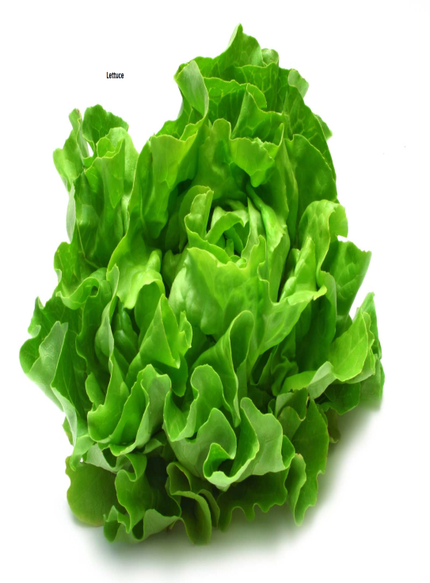Lettuce-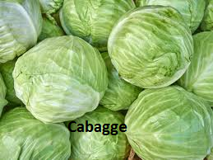

**ADVANTAGES OF INDIGENOUS VEGETABLES OVER EXOTIC VEGETABLES**

1. They are highly nutritious
2. They are easy to grow
3. They are fast maturing

**EXPLAIN THE FACTORS THAT SHOULD BE CONSIDERED WHEN IDENTIFYING A SITE FOR VEGETABLE GROWING.**

1. **Nearness to a source of water**

The site should be near a water source since vegetables require regular watering.

1. **Shading**

Heavy shading should be avoided as it -prevents light supply.

1. **Space**

The site should be large enough to accommodate the population of vegetable crop required.

1. **Topography**

The site should have a level ground. This helps prevent flooding or surface run off that may destroy the crop.

1. **Type of soil**

The soil should be deep and well drained to enhance water filtration into the soil and prevents water lodging.-

1. **Security**

The site should be located in an area well protected against damage by animals and theft by human beings. It should be properly fenced.

1. **Previous crop grown**

The site should not be the one where vegetables of the same family have been grown before. Crop rotation must be done to control pest and diseases as well as optimize use of plant nutrients.

1. **Soil fertility**

The selected site should be fertile to provide necessary nutrients to reduce on quantity of fertilizers used and promote faster growth.

**SEEDBED PREPARATION**

**DEFINE THE TERM “SEEDBED”**

* **Seedbed** is a piece of land varying in size, prepared in such a way that it is ready to receive planting materials and to allow seedling growth until they are transplanted**.**

**NB**: In a well prepared seedbed, th-e size of soil particles and depth of cultivated soil must be appropriate in order to facilitate planting and germination of seeds or subsequent establishment of transplanted seedlings.

**OUTLINE THE STEPS FOLLOWED DURING SEEDBED PREPARATION.**

1. **Marking the bed**

The first step is to mark out the bed by using a thin rope to show demarcations.

1. **Measuring a bed**

The seedbed should be measured 1 m wide with any convenient length.

1. **Tilling the land**

The seedbed is dug deeply to remove stumps, rooting system and the perennial weeds.

1. **Leveling tilled land-**

The soil clods are broken to suitable tilth using a hoe. The loose soil is then leveled using a rake to attain a uniform surface.

1. **Raising the seedbed**

After harrowing and leveling, the seedbed is raised to about 15cm above the ground level in order to improve on drainage. A sunken seedbed can be made in areas with limited rainfall to conserve water.

1. **Applying manure and inorganic fertilizers.**

The manure or inorganic fertilizers are applied in the holes dug into the soil. The manure is mixed to form a uniform mixture.

**PROCEDURES OF SOWING EXOTIC VEGETABLES**

1. The farmer must first select suitable vegetable types to grow**.**
2. The farmer should assemble the planting materials , equipment and tools
3. Organic manure is spread on the tilled seedbed and mixed thoroughly with the soil using a rake.
4. Shallow drills/furrow of 10-20 cm apart are made using a stick or a finger. The drills should be 2cm -deep.
5. Apply phosphatic fertilizer in the drills and mix with the soil.
6. The seeds are sown thinly in the furrows/dropped slightly.
7. Cover the seeds shallowly with soil.
8. Immediately apply light organic mulch to cover the seedbed. Light organic mulch protects the seed from pests; conserves soil moisture; protects the seed from being eroded by heavy rains and raises soil temperature to enhance germination.
9. Water the seedbed immediately if it is dry.

**IMPORTANCE OF EACH OF THE FOLLOWING PRACTICES IN A VEGETABLE NURSERY SEEDBED**

1. **WATERING**

* Watering is important-t in vegetable seedlings because they are sensitive to water stress.
* Watering should be done with the use of cans
* Too much watering should be avoid as it leads to water lodging, soil capping, soil erosion or washing away of the seedlings.

1. **MULCHING**

* Mulching of the nursery seedbeds is important for the following reasons

1. It reduces soil erosion
2. Minimizes evaporation of moisture
3. Improve water infiltration
4. Regulates soil temperature.
5. **SHADING**

* Construction of a shade over the nursery bed is important for the following reasons

1. It protects the seedlings from direct sun.
2. It provides a light shading so as to allow some sunlight to reach seedlings.

* The disadvantage of heavy shading is that it results in seedling etiolation.

1. **PRICKING OUT**

* Pricking out refers to the removal of excess seedlings from a nursery bed and transferring to a new nursery bed to overcome overcrowding.
* The uprooted seedlings are planted at a wider spacing in the new seedling bed to allow seedlings to grow stronger and healthy.

1. **WEED CONTROL**

* Weeds are controlled by uprooting.

1. **PEST CONTROL**

* Spray against the pests using appropriate pesticides**.**

1. **DISEASE CONTROL**

* Damping off diseases can be controlled by regulating watering accordingly.
* Spraying the nursery seedbeds with copper oxide and dithane M45.

1. **THINNING-**

* Thinning is the uprooting of the excess seedlings from the nursery seedbed to reduce seedlings competition for nutrients and sunlight.

1. **HARDENING OFF**

* Hardening off involves the gradual removal of shading materials to expose the seedlings to sunlight and reducing frequency of watering till it is finally stopped.-
* It is done two weeks to transplanting.
* Hardening off is important because it helps the seedlings to get used to the harsh conditions they will experience once transplanted from the seedbed and this causes them to establish with little setbacks.

**TRANSPLANTING**

* Vegetable seedlings should be transplanted when they are 1 month old or have 4-6 true leaves or about 10-15cm high. Some are transplanted when they are 6-8 weeks old.
* Transplanting should be done at the beginning of the rainfall season and in the afternoon or evening when weather conditions are cooler. This is done to allow the seedlings to get used to their new environment.

**PROCEDURES AND PRECAUTIONS DURING TRANSPLANTING**

1. The farmer fist has to mark the planting stations. For example, Kales and Cabbages should be 90cm x 60cm or 60cm x 60cm depending on the variety. Onions are planted at a spacing of 30cm x 8cm.
2. Watering- the seedbed is repeated on the day of transplanting before uprooting the seedlings. Watering ensures that the seedlings have a ball of soil intact around the root system.
3. Lifting the seedlings from the nursery with the use of a garden trowel.
4. Transplanting the seedlings. The seedlings are taken into the main field. The main field should be irrigated if there are no rains. Phosphatic fertilizers and insecticide such aldrin dusts are applied per planting hole and thoroughly mixed with the soils. Aldrin dust is applied during transplanting to protect the transplant from soil borne pests such as cutworms.
5. Mulching- using organic mulch such as dry grass is applied around the transplant to conserve moisture.

**DISCUSS HOW VEGETABLE SEEDLINGS CAN BE TAKEN CARE OF.**

1. **Watering**

Watering should be carried out as a routine practice if there are no rains.

1. **Light tillage**

This is done to loosen the soil for easy penetration of water.

1. **Weeding the beds**

This is done through light cultivation or through application of post-emergence herbicides. It is done to encourage vegetative growth.

1. **Fertilizer application**

* Application of nitrogenous fertilizer is done when the plants are about 20-25cm tall using to dressing method.
* Application of nitrogenous fertilizer to plants when they are 20-25cm tall is important to encourage vegetative growth.
* Second split fertilizer application of nitrogenous is done after 2-3 weeks.
* Foliar fertilizer can be sprayed directly on the vegetable foliage.

1. **Pest and disease control**

* The diseases can be controlled by application of pesticides and fungicides if the infestation is high.
* It can also be done by roguering off which is the uprooting of the diseased plants from the crop field.

1. **Staking**

* Staking is the practice of providing support to weak stems.
* Staking is used to support weak stems of tomatoes to hold them upright using a stick and strings.
* It is usually done for climbing stems.
* Staking and- stringing helps produce clean fruits and reduce plant infection by soil borne diseases and pests.
* Staking and stringing also enhances maximum absorption of sunlight and facilitates spraying of chemicals and harvesting.

**CONTROL OF PESTS AND DISEASES IN VEGETABLE GROWING**

**PESTS**

* Pests can be defined as any living organisms that destroy crops either directly or indirectly by introducing pathogenic effects.
* Pests can also be defined as a destructive organism affecting crops.
* Examples of pest can include insects, mites, nematodes, birds, large animals and rodents.

**ECONOMIC IMPORTANCE OF PESTS TO VEGETABLE CROPS**

1. Pests may cause physical destruction to vegetables by eating leaves, stems, roots, flowers or fruits.
2. Pests can cause considerable reduction in crop yields if not controlled.
3. Some pests lower the quality of the crop produced for example through piercing of holes in fruits and leaves.
4. Some of the pests are disease vectors, for example, aphids, mites, leaf hoppers and thrips transmit viruses and bacteria causing disease infections in vegetables.
5. It increases the cost of production in an attempt to control the pests through purchasing pesticides.

**THE CATEGORIES OF VEGETABLE PESTS**

**Vegetables are attacked by the following pests**

1. **Piercing and sucking pests**

* These pests pierce and suck sap from the plant tissues.
* Pests such as aphids, thrips, and mites transmit disease pathogens.
* They also cause distortion of leaves or shoots.
* They can be controlled by spraying with Malathion.

1. **Biting and chewing pests**

* These pests cause physical damage to plant leaves, stems, roots, flowers, fruits and seeds.
* Examples of biting and chewing pests include mammals (rodents), insects (army worms, locusts) and birds.
* They can be controlled by proper spacing of plants in the field crops.

**METHODS OF CONTROLLING PESTS IN VEGETABLE CROPS**

1. **Cultural control methods**

* This involves the use of agricultural practices such as resistant varieties.

1. **Physical control methods**

* This involves handing picking and killing pests.

1. **Biological control methods**

* This involves the use of other living organisms to predate on the pests.

1. **Integrated pest management**

* This is a strategy of combining various pest control methods.

1. **Legislative pest control method**

* This involves creating laws and regulations and enforcing them.
* The laws are established to control of cross border transfer of agricultural materials to prevent entry of pests.

**DISEASES IN VEGETABLES**

* Firstly, **diseases** are defined as an alteration in the physiological state of a plant on its parts which interrupts normal functioning.

**CATEGORIES OF VEGETABLE PESTS**

1. **Fungal diseases**

* These are caused by fungi.
* They attack roots, leaves, stems and fruits
* They spread by structures called spores that germinate on plant tissues and are carried by water, wind and vegetable pests.
* Example of fungal disease is the tomato blight**.**

1. **Viral diseases-**

* These re caused by viruses.
* They attack the leaves, stems and fruits
* Examples of viral diseases include

1. Tomato mosaic
2. Chilly mosaic (peeper mosaic).
3. Chilly leaf curl
4. Pea seed borne mosaic
5. Cucumber mosaic
6. Green mottle
7. Yellow vein mosaic of okra
8. **Bacterial diseases**

* These are caused by bacteria.
* They attack stems and leaves.
* An example of bacterial disease is bacterial wilt.

**CONTROL METHODS OF VEGETABLE DISEASES**

1. **CULTURAL METHODS**

This involves routine agricultural practices carried out in crop production.

**The cultural methods include**

* Selecting disease free fields.
* Early planting for the crop to avoid attack by disease
* Early harvesting to avoid attack by diseases
* Wide spacing o-f the crops to reduce spread of disease and to control vector movement.
* Planting of disease free planting materials.
* Practising field sanitation
* Rogueing- this involves uprooting and destruction disease plants to reduce the spread of diseases and kill the pathogens.
* Growing resistant varieties.
* Intercropping which create a physical barrier to pathogen and vector spread.
* Crop nutrition through application of fertilizers and manure to enhance robust growth of plants to resist disease attack.
* Practising crop rotation.

1. **PHYSICAL/MECHANICAL METHOD**

**This involves the use of the following:**

1. Heat treatment where pathogens are exposed to very high temperatures that kill them.
2. Planting materials which are treated with electromagnetic radiation such as x-rays to kill the pathogens.
3. Flooding the fields to reduce or eliminate the soil pathogens and nematodes.
4. **BIOLOGICAL METHOD**

* This involves the use of other organisms to kill the pathogens**.**
* Examples include

1. Use of Bacillus bacteria as a control agent of other soil borne pathogens.
2. Development of resistant varieties through plant breeding.
3. Planting trap crops to attract the vectors and pathogens hence reducing attack.
4. **LEGISLATIVE METHOD**

* This method involves creation of laws or regulations to control the movement of plant materials within the country and across the country borders.
* This method includes **Quarantine** that prevents the introduction of diseased plants materials into disease free area**.**

1. **CHEMICAL METHOD**

* This involves use of a variety of chemicals that kills the pathogens or prevent the pathogen from attacking the plants.
* The chemicals used in chemical methods include

1. **Fungicides**- use-d to control fungal disease.
2. **Antibiotics -** used to control bacterial diseases
3. **Nematicides -** used to control nematodes
4. **Acaricides-** used to control mites that are vectors of viral diseases.

**HARVESTING VEGETABLES**

* Vegetable crops should be harvested on time in order to reduce field losses through destruction by rain, pests and diseases.
* Harvesting the crops in the wrongs stage may lower the quality of produce or renders the product unusable.

**FACTORS THAT DETERMINE TIME OF VEGETABLE HARVESTING**

1. **Intended use of the crop**

* Tomatoes for processing are harvested when purely ripe whereas peas can be harvested when for their pods as vegetable or processed at green stage.

1. **Taste and preferences of the consumer**

* Some people prefer immature carrots while some prefer the mature hardened carrots.

1. **Market demand-**

* A crop can be harvested earlier when the market demand is and this allows the farmer to benefit from the high market prices.

1. **Pests and disease outbreak**

* A crop can be harvested earlier to prevent damages by pests.

1. **Prevailing weather conditions**

Carrots need wet weather for harvesting while onions need dry weather.

**METHODS OF HARVESTING VEGETABLES**

1. **Picking**

This method involves nipping off the leafy parts of the vegetables. It also involves nipping off legume pods from the stalk in sow pods and French beans

1. **Uprooting**

* This method involves pulling out the root tubers of root vegetables such as carrots and beetroots from the soil.
* It is used when the soil is still wet at the time of harvesting.
* A plough called carrot lifter can be used to loosen soil before lifting or pulling. The tubers are then washed before packing in bags.

1. **Cutting**

* This is the method of harvesting some vegetables whereby the vegetables are harvested by cutting the stem using a sharp knife.
* For example, cabbages are cut at the base of the head where the stem is attached.
* Examples of vegetables harvested using this methods are cabbages, asparagus, broccoli and cauliflower.

1. **Digging**

* This method is used to harvest onion tubers when the leaves start withering at 5-8 month old.
* The tubers are dug out using a forked hoe when leaves are dried.

**CHAPTER 10: CLASSES OF LIVESTOCK**

**The two classes of livestock based on their digestive system are**

1. **RUMINANT ANIMALS/POLYGASTRIC**

* These are animals that chew cud or regurgitate the foods i.e. pushing back the food from the stomach to the mouth for further chewing.
* The four chambers of ruminants include **reticulum, omasum, rumen and Abomasum,** These are in the diagram below:

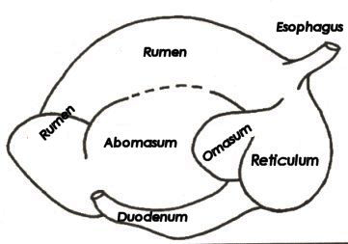

1. **NON-- R-UMINANT ANIMALS/MONOGASTRIC**

* These are animals which do not chew cud and have one simple stomach.
* Examples of non-ruminants include

1. **Chicken**

* The chicken has true stomach and the second chamber known as Gizzard.
* The gizzard is absent in other non-ruminants.
* Below is the diagram of the chicken showing external parts.

- -- 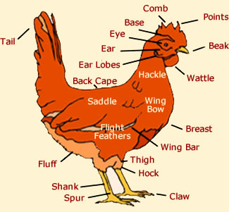

1. **Pigs**

* The pigs do have appendix unlike in other non-ruminants**.**
* **Below is the diagram that shows a pigs**

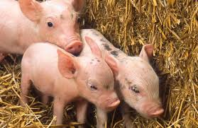

**THE DIGESTIVE SYSTEM OF A RUMINANT /PLYGASTRIC ANIMALS**

* Rumina-n-ts are animals are animals that chew cud.
* Chewing the cud refers to pushing back the feed from the stomach to the mouth for further chewing i.e. regurgitate.

- - 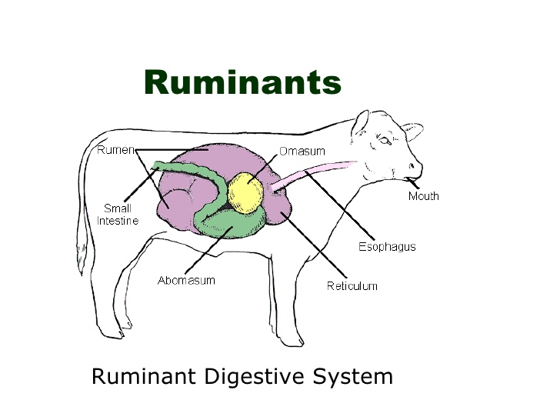

**CHAMBERS OF THE STOMACH OF RUMINANT ANIMALS**

The stomach of the ruminants/polygastric animals I divided into four chambers. These four chambers include

1. Rumen(Paunch) or 1st stomach
2. Reticulum (Honeycomb) or 2nd stomach
3. Omasum (Manyplies, book or bible) or 3rd stomach
4. Abomasum (True stomach) or 4th stomach

The diagram below shows the four chambers of the stomach of the ruminant animal:

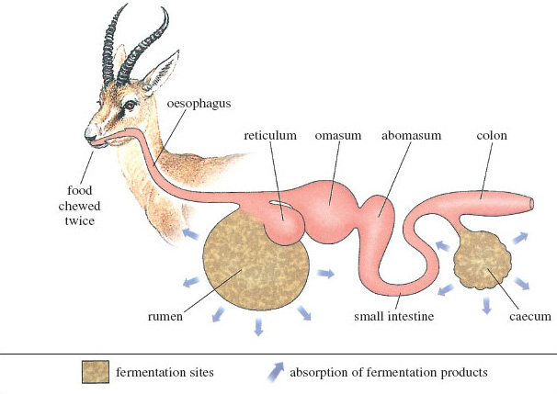

**THE FOUR CHAMBERS OF THE STOMACH OF RUMINANT ANIMAL**

--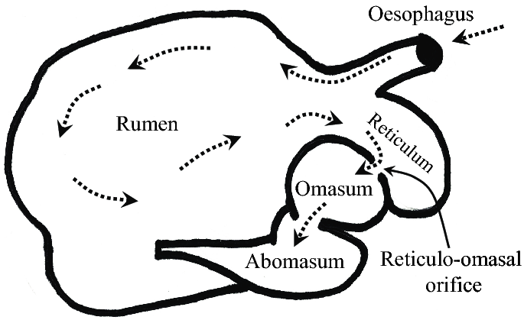

**EXAMPLES OF RUMINANT/POLYGASTRIC ANIMALS**

These include

1. Cattle
2. Sheep
3. Goats

**DIGESTION IN THE MOUTH**

* The food is chewed in the mouth with the help of the teeth where it is mixed with saliva and then passed onto the rumen.
* There is no enzymatic digestion in the mouth of ruminant animals **because** ruminants do not have ptyalin enzymes in the in the saliva.
* R-uminants produce a lot of saliva which act as a lubricant.

**DIGESTION IN THE RUMEN**

* R-umen is the largest compartment in a mature ruminant animal**.**
* The function of the rumen is to serves as a temporary store for food ingested by an animal.
* During the storage, food is churned, mixed and softened with water in the rumen.
* Rumen contains microorganisms such as bacteria and protozoa.
* The function of the microorganisms (bacteria and protozoa) found in the rumen of ruminant animals is to act on cellulose and fermenting it.
* Th--e microorganisms in the rumen obtain their energy from fatty acids and simple sugars which are the products of carbohydrate digestion.
* There is no secretion of digestive enzymes in the rumen.
* See the rumen in the diagram below

- 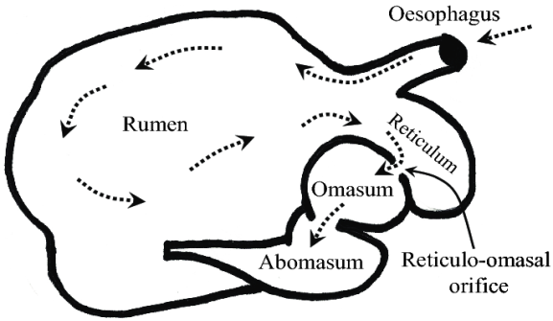

**FUNCTIONS OF THE MICROORGANUSMS FOUND IN THE RUMEN OF THE RUMINANTS**

1. Digestion of carbohydrates

* Micro organisms digest cellulose which produces volatile fatty acids such as propionic, acetic and butyric.
* The fatty acids are absorbed through the rumen wall into the blood stream and provide energy to the animal.
* Some of the fatty acids in the rumen are utilized by the microorganisms for -the synthesis of important nutrients.

1. Digestion of fats

* Fat present in the food is broken down into fatty acids and glycerols by the micro organisms.

1. Digestion of proteins
2. Synthesis of essential amino acids from nitrogenous compounds such as urea.
3. Synthesis of vitamin B complex and vitamin

**RE-GURGITATION/CHEWING THE CUD**

* From the rumen the improperly chewed food is regurgitated for proper re-chewing in the mouth.
* Chewing the cud refers to sending back the food from the rumen to the mouth for further chewing.

**GASES PRODUCED IN THE RUMEN**

* Gas-es such as methane and carbon dioxide are produced as a result of the digestion in the rumen.
* Methane and carbon dioxide produced in the rumen are belched out as their accumulation can cause bloating.

**- DIGESTION IN THE RETICULUM**

* The diagram below shows the four chambers of the stomach of the ruminant. See -the reticulum in the diagram.

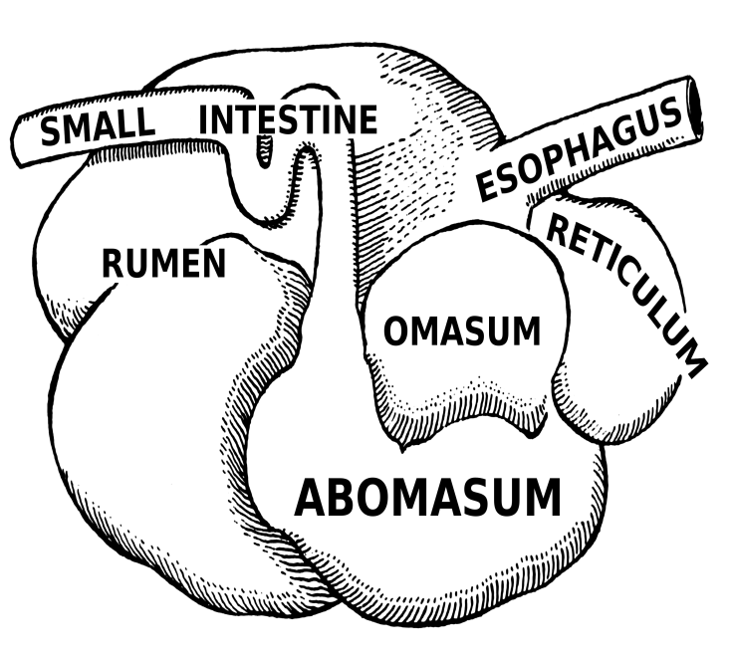

* The function of the reticulum is to sieve and separate fine materials from coarse ones in the food.
* Fine materials pass on to the next compartment, the **omasum** where as coarse materials are retained in the reticulum together with foreign materials such- as stones or hard pieces of wood.
* There- is no enzymatic action in the reticulum.

**DIGESTION IN THE OMASUM**

* The function of the omasum is to absorb water from the food as it passes to the Abomasum.
* It is also used to grind and sieve food particles by means of its folds.
* Food is stored temporarily in the omasum.
* There is no secretion of digestive juices in the omasum.

**DIGESTION IN THE ABOMASUM**

* This is the true stomach of the ruminant animals where most of the digestion takes-- place.
* It produces hydrochloric acid and enzymes, pepsin and renin.
* The function of Pepsin and rennin produced in the Abomasum is to completes the protein digestion
* The function of hydrochloric acid is to

1. Kill microorganisms within the food substances that come from the omasum.
2. Provide suitable medium (acidic) condition for pepsin enzyme to function.

* After digestion in the Abomasum, the food passes on to the other parts of the digestive system where digestion proceeds normally like in other animals.

**CAECUM OF THE RUMINANTS**

It contains microorganisms which assist in further digestion of undigested cellulose.

**DIGESTIVE SYSTEM OF A NON -RUMINANT THE CHICKEN**

* The chicken has true stomach and the second chamber known as Gizzard.
* The gizzard is absent in other non-ruminants.

**DIGESTIVE SYSTEM OF POULTRY**

The poultry have the following features which make tem to different from other animals.

1. A beak instead of a normal mouth.
2. Lack teeth hence no chewing of food.
3. A crop which is found between the mouth and the stomach.
4. Presence of proventriculus and ventriculus (gizzard).
5. Two Caecae each with a blind sac. Caecae have no digestive importance.
6. The large intestine is short in length.
7. The cloaca is used for both excretion of urine and faeces. It is also the opening for the genital system.

**DIGESTION IN POULTRY**

**-** 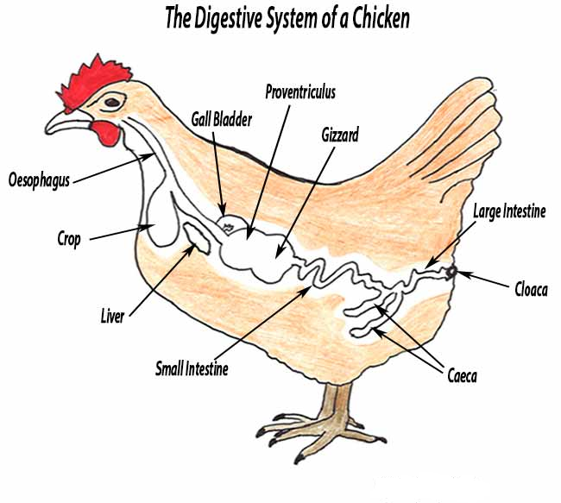

-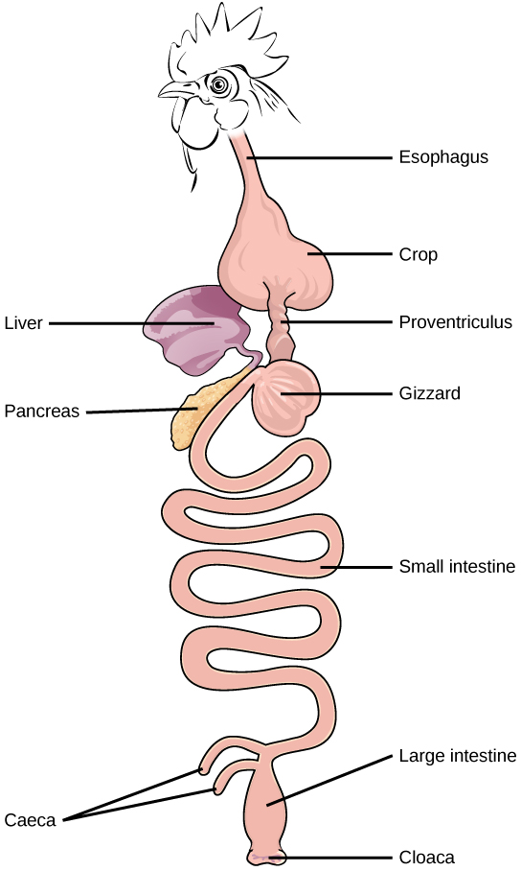

**Describe the process of digestion in the following organs of a poultry.**

1. **THE MOUTH**

* Poultry pick up food and swallow it whole to the crop.
* The poultry have Ptyalin in saliva but hardly act on food because the food is quickly swallowed.
* The saliva in the mouth of the poultry acts as a lubricant and helps in the swallowing of food.

1. **THE CROP**

* This is an enlarged part of the Oesophagus of the digestive system of the poultry.
* The function of the crop in poultry is to act as a reservoir for holding, moistening and macerating the food.
* The crop also secretes mucus which is used to soften and moisten the food.
* The food is forced to the proventriculus by the contraction of the crop.

1. **THE PROVENTRICULUS/GLANDULAR STOMACH**

* The function of the Proventriculus is to secrete gastric juice which contains pepsi-n and hydrochloric acid.
* The function of the hydrochloric acid is to provide an acidic medium which is appropriate for the functioning of enzyme pepsin.
* Pepsin digest proteins by breaking down into peptides.
* There is minimal digestion in the Proventriculus beccause it has a small cavity.
* The food is quickly forced down into the Gizzard by the contraction of the Proventriculus.

1. **THE GIZZARD**

* The gizzard ha tough muscles whose movement enable the food to be crashed into powder.
* The gizzard contains grit.
* The function of the grit found in the gizzard is to grind food particles
* There is enzyme secretion in the gizzard.
* From t-he gizzard, the food moves to the intestiners.

**WHAT ARE THE ROLES OF THE FOLLOWING ORGANS IN POULTRY?**

1. **Crop**

* It act as a reservoir for holding, moistening and macerating the food.

1. **Proventrculus**

* It secrete gastric juice which contains pepsin and hydrochloric acid that provide an acidic medium for enzyme pepsin to start digestion of proteins

1. **Giczzard**

* It has tough muscles that crash food into powder.
* It contains grit which grind food particles

**THE DUODENEUM AND INTESTINES**

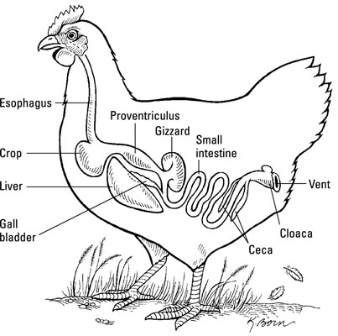

1. **Pancreas**

* The pancreas produces pancreatic juice that mixes with food in the duodenem.
* The pancreatic juice contains three enzymes namely

1. Pancreatic amylase which acts on carbohydrates
2. Tryp-sin which acts on proteins
3. Lipase which acts on lipids
4. **Liver**

* Liver produces bile which emulsifies fats in the duodenum.

1. **Small intestine**

* The small intestine produces intestinal juice which contains enzymes lipase , maltae, sucrase and peptidase which complete protein, carbohydrate and lipids digestion.

1. **Villi in the small intestine**

This is where absorption of food takes place.

**CAECUM**

* This contains two enzymes namely amylase and cellulase.
* Cellulase digests cellulose into simple carbohydrates
* The amylase completes the digestion of carbohydrates.

**CLOACA**

* This is where the undigested food (faeces) is passed out through the vent from the intestines.

**THE DIGESTION IN A PIG**

**DIGESTION IN THE MOUTH**

* The lower lip and teeth are used to ingest and masticate food.
* The food is mixed with saliva in the mouth.
* Saliva contains Ptyalin enzyme which does not get enough time to act on the food.
* The enzyme is not significant in the mouth of the pigs.

**DIGESTION IN THE STOMACH**

* The stomach is used for temporary storage for food.
* It also secretes gastric juice which contains **hydrochloric acid and two enzymes pepsin and rennin.**
* The hydrochloric acid provides an acidic medium which creates an optimum condition-n for pepsin to work well.
* Pepsin breaks down proteins into smaller molecules called peptides.
* Renin causes the curdling of milk protein in new born.
* In young pigs, rennin acts on casein and converts it into curdled milk which remains in the stomach long enough to be broken down into amino acids.

**DIGESTION IN THE SMALL INTESTINE**

1. **Pancreas**

* The pancreas produces pancreatic juice that mixes with food in the duodenem.
* The pancreatic juice contains three enzymes namely

1. Pancreatic amylase which acts on carbohydrates
2. Trypsin which acts on proteins
3. Lipase which acts on lipids
4. **LIVER-**

* Liver produces bile which emulsifies fats in the duodenum.

1. **Small intestine**

* The small intestine produces intestinal juice which contains enzymes lipase , maltae, sucrase and peptidase which complete protein, carbohydrate and lipids digestion.

1. **Villi in the small intestine**

* This is where absorption of food takes place.

**DIGESTION IN THE LARGE INTESTINE**

* The caecum and colon contain microorganism

**Functions of the microorganisms found in the caecum and colon**

1. They help in the digestion of cellulose into fatty acids.

* The fatty acids include acetic acid, propanic acid and butyric acid. They are volatile and are absorbed in the large intestine.
* Cellulase digests cellulose into simple carbohydrates
* The amylase completes the digestion of carbohydrates.

1. They a-ct on undigested proteins to produce various products which include amino acids and gases such as hydrogen sulphide, indole and akatole**.**

* Indole and skatole gases are responsible for the smell of faeces**.**

1. They synthesize vitamin B though in relatively small quantities.

**NB**: There is also water absorption in the colon.

**SIMILARITIES BETWEEN RUMINANTS AND NON-RUMINANTS**

1. Digestion in young ruminants is similar to that in non- ruminants since they have not developed the rumen- rectum complex.
2. The last stage of protein digestion occurs in the small intestines in both cases
3. Absorption of water occurs in the colon in both ruminants and non-ruminants.

**DIFFERENCES BETWEEN RUMINANTS AND NON-RUMINANTS**

|  |  |
| --- | --- |
| **Ruminants** | **Non-ruminants** |
| Chew cuds | Do not chew cud |
| Have four -stomach chambers | Have one stomach |
| Regurgitate food | Cannot regurgitate food once swallowed |
| Have microorganisms in the rumen that digest cellulose | Do not have microorganisms in the stomach hence cannot digest cellulose. Except those animals with microorganisms in the caecum. |
| Have no Ptyalin in saliva hence no enzymatic digestion in the mouth**.** | Have Ptyalin in the saliva hence enzymatic digestion starts in the mouth**.** |
| -Digestion and absorption takes place in the rumen, abdomen and in the intestines | Most digestion and absorption occurs in the stomach and small intestines. |
| Have alkaline saliva due to the presence of ammonia | The saliva is neutal in pH |

**CHAPTER 11: CHICKEN PRODUCTION**

* Poultry refers to all domesticated birds.
* Examples of domesticated bird include

1. Chicken
2. Ducks
3. Turkey
4. Geese
5. Guinea fowl
6. Ostrich

**IMPORTANCE OF KEEPING CHICKEN**

Chicken is kept for

1. Eggs
2. Meat
3. Fathers
4. Sporting for example cock fighting.

**BRREDS OF CHICKEN**

The two main breeds of chicken include

1. **Local breeds**

* These are indigenous breeds which are normally kept for both meat and eggs.
* Examples of local breeds of chicken include

1. Chipazga
2. Chalida
3. Yakuda
4. Yoyela
5. Yankhanga

**CHARACTERISTICS OF INDIGENOUS BREEDS**

1. They cannot easily categorized into breeds due to cross breeding.
2. They are low yielding. Hence the produce fewer and small sized eggs per year.
3. They are hardy.
4. They are more resistant to parasites and diseases are highly adaptable to tropical conditions.
5. They are reared under village system and for subsistence
6. **Exotic breeds**

* These are breeds of chicken which originated from temperate regions, for example, Europe.
* Some of them are kept for meat while others are kept for eggs.

**CATEGORIES OF EXOTIC BREEDS OF CHICKEN**

These include

1. **Light breeds/Layers**

* These are breeds of chicken which are kept for egg production.

These breeds

1. Are medium in size
2. never go broody/poor egg sitters
3. Are excellent egg layers
4. Are poor producers of meat
5. are light in body
6. their combs are full, red and waxy

* Examples of light breeds include

1. White Leghorn
2. Brown Leghorn
3. Black Leghorn
4. Anacona
5. Minorcas
6. Exchequer

**THE LEGHORNS**

* These are originated from Italy.
* Examples include

1. **White Leghorn**

This is the most popular and has plumage, yellow legs and beak

1. **Brown Leghorn**

This breed of chicken has brown plumage; the hackles and saddle feathers of the cocks are red.

1. **Black Leghorn**

* This breed of chicken is black all over but has yellow legs.
* They are nervous and are easily frightened
* They produce white eggs.

1. **Heavy breeds**

* This is a breed of chicken kept for meat production.
* They are known as broilers
* They have a high conversion rate of feeds into meat.
* They provide high quality, go broody, heavier, grow fast and hens lay few eggs.
* Examples include

|  |  |  |
| --- | --- | --- |
| **Breed** | **Country of Origin** | **Purpose** |
| Light Sussex | Britain | Kept for meat |
| Cornish White | England | kept for meat |
| Cornish Dark |  | Kept for meat |
| Jersey Black Giant |  | Kept for meat |

1. **Dual purpose**

* These breeds of chicken are kept for both meat and egg production.
* These breeds of chicken

1. Have a tendency to go broody
2. Have a carcass of good quality
3. Are rarely exhibit cannibalism
4. Are disease resistant

* Examples of Dual purpose breeds of chicken which are recommended for farmers in Malawi include

|  |  |  |
| --- | --- | --- |
| Breed | Place of Origin | Features |
| Rhode Island Red | America | Dark red/brown red in colour |
| Black Australops | America | The plumage is chestnut red |
| New Hampshire Red | Australia | Shiny black, red comb & wattles |

1. **Hybrids**

* These are birds bred to suit a particular management condition.
* A hybrid is a bird produced by crossing two different pure bird breeds.
* They are superior in performance, can attain 2kg in 56 days and can lay over 220 eggs per year.
* They are bred from hybrid vigour to gain weight quickly and to lay more eggs than the pure breeds.
* They have a better resistance to diseases and can easily adapt
* They have a better feed conversion
* Examples of hybrids
* Thorn Ber 404 and 704
* Kigwaru Queen
* Hyline Stock
* Shavers
* Sterling
* Ross
* Supper White
* Brown Eggers
* Issa Brown

**PARST OF A CHICKEN**

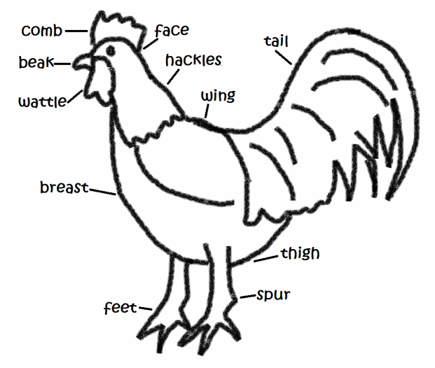

**QUALITIES OF A GOOD HOUSE**

**It should have the following qualities**

1. **Lighting**

* It should adequately lit to enable proper feeding and carrying out of other management practices by the farmer**.**
* Dimming of light is necessary to discourage vices such as cannibalism and egg eating.

1. **House size**

* It should be large enough to avoid overcrowding which may lead to fat spread of diseases, parasites and discourage cannibalism.

1. **Security**

* The house should be draught free, by having solid leak proof walls, to protect birds from rain.
* It should be strong enough to protect the birds from predators.

1. **Ventilation**

* The house should be well ventilated to reduce dampness which favours development of diseases.
* Open areas with mesh wire encourages ventilation.

1. **Ease of cleaning**

* It should be easy to clean to maintain healthy birds.

1. **Location**

* It should be located in a well drained area to prevent dampness**.**

1. **Fittings**

* The house should have adequate nests or boxes for laying, feeders, waterers or perches and brooders.

**HOUSING SYSTEMS OF CHICKEN**

1. **INTENSIVE SYSTEM**

* This is a system of keeping large number of birds totally enclosed in a house.
* In other words, it is a system of rearing birds where they are confined in houses or structures and all their production requirements are provided for within the poultry housing unit.
* All the feeding requirements for the birds are supplied by the farmer.
* Examples of intensive system of housing chicken include

1. **DEEP LITTER POULTRY REARING SYSTEMS**

* Deep litter system is a method of rearing poultry where the birds are confined within a big house. The house usually has no partition and the floor is covered with absorbent litter.

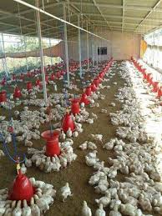

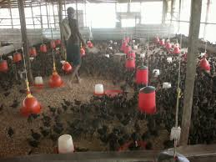

Requirements of Deep litter system has the following

1. **Site**

The land should be well drained. A trench should be dug around the house to drain away excess water around the poultry house.

1. **House**

* It should be made of solid material up to at least 60 com above the ground surface. This helps to maintain the litter in good condition, to stop entry of external water, to prevent loss of litter and to eliminate floor draughts.
* It should be well ventilated and should have a leak- proof roof.

1. **Litter**

* It should be supplied with litter of good absorbent ability.
* The recommended litter materials include

1. combination of 50% sawdust and 505 wood shaving
2. Combination of 25% cut straw and 755 sawdust.
3. Coffee husks, 100%
4. Crushed maize cobs, 100%

* The litter should always be kept dry and dust free.
* Perches should be shifted occasionally to spread droppings all over the litter.

1. **Feeders**

* For feeding chicken
* Use automatic feeders that allow feed to flow by gravity.
* The feeders and waterers should have pointed tops to discourage birds from perching on them.

1. **Waterers**

* For providing water to the chicken.

1. **Laying** **nests**

* For laying eggs
* Use of trap nets is preferred. These nests only allow birds in and do not allow them to exist.
* The trap nests help the farmers to identify the poor layers.

1. **Dropping pit**

* A trench is made within the poultry house which should not be more than 60cm deep and should be covered by wire netting.
* The feeders and waterers are placed above the trench. The droppings are removed once a year.
* The trench is necessary in wet climatic regions. In dry climatic areas, it can easily become a breeding ground for rats.

1. **Perches/Roots**

* Roots are wooden frames on which birds sit on to rest.
* Perches should allow a space of 22-30cm per bird and should be 1.2m high. It should be movable to allow even spread or easy removal of droppings outside the building for regular cleaning.

**Advantages of deep litter system**

1. There is high stocking rate hence high returns per unit area of land.
2. There is low labour requirement
3. There is fast accumulation of manure.
4. The system is appropriate for rearing breeding stock.

**Disadvantages of deep litter system**

* Provision of individual attention to birds is difficult.
* Vices such as cannibalism and egg eating are very common.
* The system provides conditions which encourage broodiness in birds.
* High incidences of **coccodiosis** and parasite infestation particularly when hygiene standards are compromised.

1. **BATTERY CAGE SYSTEM**

* Battery cage is a method of farming where birds are confined in wired cages.
* The cages are normally in rows called tiers and have a slopping floor to allow easy rolling of eggs to the collecting tray.
* The cages are arranged back to back and are raised 60 -90cm feet above the ground for ease of cleaning the floor.

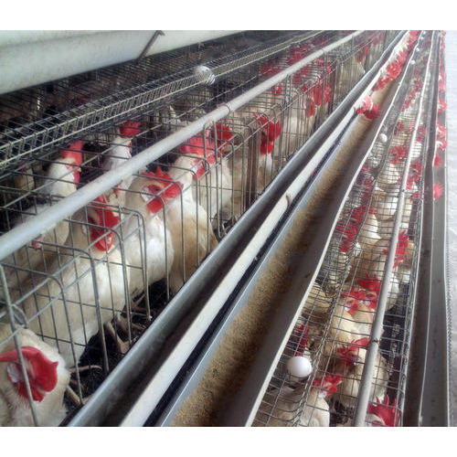**Advantages of battery cage system**

1. It has the highest stocking rate because one is able to utilize the whole space in the house.
2. Records per individual bird can easily be kept.
3. The performance of the birds is highest under this system since there is reduced movement of the birds.
4. Vices such as egg eating and cannibalism are rare.
5. Clean eggs are produced since they roll off immediately after laying into the collection trays.
6. It minimises broodiness among the birds as they do not reach their eggs.

**Disadvantages of battery cage system**

1. It requires very high initial cost which is out of reach to many farmers.
2. It requires very high level of management.
3. The system is not suitable for breeders and broilers.
4. The cage is uncomfortable to the birds and may lead to bruises on combs, toes and breast, as they try to contact the birds they do not reach their eggs.

**Semi-intensive**

* This system of chicken rearing includes the sun system and fold system.

1. **Sun system**

* This consists of a house in the middle of partitioned areas (runs).

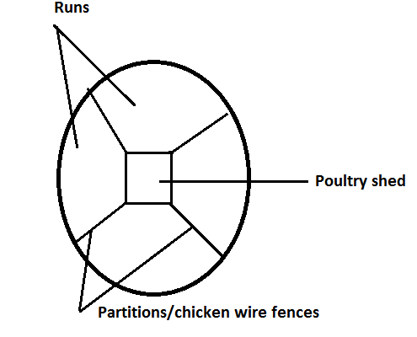

* Laying nets are also placed in the house.
* The house should be movable so as to facilitate easy re-location from one run to another. It may also be constructed at the centre of several runs for ease of sharing the poultry house.
* The land should be partitioned to allow rotation. This reduces build up of diseases and parasites.

1. **Fold system**

* This is a system where birds freely eat vegetation but are confined in small movable houses known as folds or arks.
* One third of the fold is roofed to provide shelter and the rest is left open but enclosed by chicken wire.
* The unroofed part allows in sunlight and is used for exercise and feeding on grass.
* The roofed part contains waterers (drinkers) laying nests and feeders.
* The folds should be moved to a new ground daily to reduce build up of diseases, provide fresh grass to the birds, and avoid accumulation of dropping.

**Advantages of Semi-intensive system**

1. Manure is uniformly spread in the field.
2. Worm infestation and incidences of coccodiosis are reduced. This is because folds are moved regularly and hence birds do not come into contact with their droppings.
3. There is no need for fencing.
4. Less feeding costs since the birds supplement the feed with insects and grass.

**Disadvantages of semi-intensive system**

1. Foods last for a short period because of too much handling.
2. Few birds are kept per fold.
3. Labour requirements are fairly high because one has to work on many folds.
4. Egg production records per bird are difficult to keep.
5. The returns per unit land are relatively low.
6. **Extensive systems**

* This is a system where birds are reared in an open field where they move about and feed on grasses, insects and grit to supplement normal feeding**.**
* This system is also called free range or traditional system.
* It is cheap to maintain. The farmer does not spend money buying feeds for the chicken.
* The chicken obtains a balanced diet by eating different types of food from the surrounding.
* The house is equipped with laying nests and brooding. Waterers are located within and outside the house.
* In the evening, the chickens are allowed to get into their house.

**FEEDING OF LAYERS**

* The layers are fed on layers mash, green leafy vegetables, grit, soluble grit (oyster shells) or sand and adequate water should also be provided..
* Grit is important because it helps in digestion.

**FEEDING OF GROWERS/PULLETS**

* Poultry are considered to be growers
* Growers are fed on growers mash that contains 16-17% crude protein, vitamins and trace elements.
* Supplement the growers mash with grains and greens.
* Hang the greens to provide exercise for the birds
* Oyster shells is introduced to the diet of chicken because it provides enough calcium which is necessary for hard egg shell formation.

**DISSEASES OF POULTRY**

1. **VIRAL DISEASES**

* These are diseases caused by **virus** and are highly contagious and infectious disease of poultry.
* Examples of viral diseases of poultry include

1. **Newcastle**

* It is caused by paramyxovirus.
* It affects mainly poultry especially at the age of 3 months to one year.
* It is transmitted through inhalation and ingestion of contaminated feeds, discharges from the nose and mouth, droppings and eggs from affected birds.
* Incubation period is 5 to 7 days.

**Symptoms**

* Nasal discharges forcing the birds shake the head in order to clean them.
* Profuse green diarrhoea.
* Coughing and sneezing.
* Drooping of wings.
* Closing of eyes all the time.
* The beaks remain wide open and the neck is strained.
* Walking backwards and in circling motions
* Twisting of head and neck
* Gasping for air and producing a harsh during breathing.

**Control**

* Vaccinate birds at regular intervals that are at 3 days old.
* Destroy the whole flock in case of an outbreak.
* Imposition of quarantine.
* Ensure proper farm hygiene; put football at the door of poultry unit.
* Disinfect poultry house before bringing in new stock.
* Proper stocking rates in the poultry house.
* Obtain stock from reputable sources.

**NB**: There is no effective treatment for Newcastle disease.

1. **Fowl pox**

* It is caused by fowl pox viruses.
* It affects mainly chicken, turkey, pigeon and all other classes of birds.
* It is transmitted through inhalation, direct contact and biting flies.
* Incubation period is 3 to 14 days.

**Symptoms**

* Wide spread lesions on the skin, comb wattles, legs, vent, feet and under the wings.
* Presence of lesions inside the mouth and throat mucous membranes.
* Watery discharges from the eyes and nostrils in the early stages of infection.
* Difficulty in breathing and swallowing.
* Loss of appetite.
* Fall in egg production.

**Control**

* Carry out regular vaccinations.
* Isolate the sick birds.
* Observe hygiene in the poultry house.
* Burn or burry dead birds.

**Treatment**

* Treat secondary infections through application of iodine on the vesicles.

1. **Gumboro or infectious Bursal disease**

* It is caused by the infectious bursal disease virus.
* It affects mainly poultry aged between 3-6 weeks.
* It is transmitted through faeces and other contaminants that is, feeds and beddings.
* Incubation period is 2 to 3 days.

**Symptoms**

* White diarrhoea
* Soiled vents and feathers.
* Birds exhibit unco-ordination of body systems.
* Pecking of vent due to irritation.
* Inflammation of cloaca.
* Immuno-suppression predisposing birds to coccodiosis and other diseases.
* Swollen bursa of fabricius gland above the vent of the birds.

**Control**

* Regular vaccination through the eyes and in drinking water.
* Observe poultry hygiene.
* Have the right population of birds in the house.
* Kill, burn and burry infected birds.

**Treatment**

* Administer antibiotics, multivitamins and fluid to the affected birds.

1. **PROTOZOAN DISEASES**

* These are diseases caused by protozoa.
* The main example of protozoan disease of the poultry is coccodiosis.

**Coccodiosis**

* It is caused by Coccidia of the Eimeria species.
* Its incubation period is about 7 days.

**Symptoms**

* Copious bloody diarrhoea.
* The birds have ruffled feathers.
* Birds appear dull and sleepy.
* Sudden death in birds, rabbits and kids may occur.
* Dropping wings.

**Control**

1. Maintain hygiene in animal and poultry houses.
2. Use prophylactic drugs in food or drinking water for poultry and rabbits.
3. Isolate infected animals.
4. Maintain appropriate numbers in animal houses.
5. **BACTERIAL DISEASES**

* These are diseases caused by bacteria in poultry.
* These diseases include

1. **Fowl Typhoid**

* It is caused by bacterium known as Salmonella gallinarum.
* It is transmitted through the eggs and droppings.
* Incubation period is 4-5 days.

**Symptoms**

* Dullness
* Respiratory problems
* Yellow-green diarrhoea.
* Dropping wings and sleepy eyes.
* Whitish pasting of vents.
* Birds huddle together near a source of heat.
* Pale wattles and combs.
* Birds die within 3 to 6 days.

**Control**

* Regular vaccination of the birds.
* Kill all affected birds and dispose them off.
* Maintain cleanliness in the poultry house.
* Obtain eggs for hatching from reputable source.
* Provide sulphur drugs in poultry feed or drinking water.

1. **Fowl cholera**

* It is caused by bacteria which include Pasteurella multocida and Pasteurella auiseptica.
* It affects mainly chicken, turkey, pigeon and all other classes of birds.
* It spreads through the following ways
* Direct contact between infected and healthy ones.
* Wild rodents and birds
* Infection from contaminated feed bags, feeding and drainage equipment and human clothing as they introduce bacteria into the farm.
* Fowl cholera are classified into two types which include

1. **Acute type**

This disease takes a short period from infection to when the first symptoms appear usually 1-3days.

It develops fast and some birds may die hours from infection. It results in loss of large number of birds.

**Symptoms**

* Fast and difficulty in breathing
* **Green diarrhoea**
* Rate of respiration is increased.
* Wattles and comb are pale red but later turn dark-red**.**
* Reduced/depressed laying of eggs.
* In breeding stock mating is reduced hence reducing fertility and productivity of the flock.
* Enlargement of the liver
* Haemorrhage of the intestines.
* Haemorrage of the heart and presence of fluid in the pericardial membrane.

1. **Chronic type**

This is the disease where the birds take long time to show symptoms of infection.

There are only a few losses.

**Symptoms**

* Running nostrils
* The face, eyes and wattles may become swollen for both acute and chronic types.
* Enlargement of the liver
* Haemorrhage of the intestines.
* Haemorrage of the heart and presence of fluid in the pericardial membrane.

**Treatment**

* Administer antibiotic Aureo mycin in drinking water or tetracycline in feeds.
* Administer chloamphemical.

**Control**

* Killing infected birds and dispose off the birds by burning or deep burying in time.
* Proper sanitation
* Routine vaccination should be done at 10 and 14 weeks old.

**PARASITES OF CHICKEN**

Parasites are organisms which obtain part or all their nourishment from other organisms, the hosts.

Chicken suffer adversely as hosts to a variety of parasites.

**CLASSIFICATION OF CHICKEN PARASITES**

1. **EXTERNAL PARASITES(ECTOPARASITES)**

* These are parasites which are usually found on or under the skin of the hosts.
* Examples of external parasites include

|  |  |  |
| --- | --- | --- |
| **EXTERNAL PARASITE** | **EFFECT** | **CONTROL** |
| Fleas | * Causes irritation * anaemia | * Applying petroleum jelly on the affected parts. * Dusting the poultry pens with pyrethrins. * Observing cleanliness |
| Tampans/Fowl tick | * Causes anaemia * Irritation * Decreased egg   production | * Control rodents as they bring ticks to the chicken * Spraying/dusting the houses with acaricides * Rear chicken in battery cages |
| Legmites/scaly legmites | * Causes irritation * Cause anaemia * Birds lose weight * Reduce egg production | * Disinfects poultry houses * Apply petroleum jelly on the legs * Dusting the birds with acaricides |
| Lice | * Causes irritation | * Dusting the birds with insecticides * Proper sanitation |

1. **INTERNAL PARASITES(ENDOPARASITES)**

* These are parasites that live inside the body of the host.
* Examples include

1. **Roundworms**

* They inhabit the alimentary canal of chickens and other livestock such as cattle, pigs, goats and sheep**.**

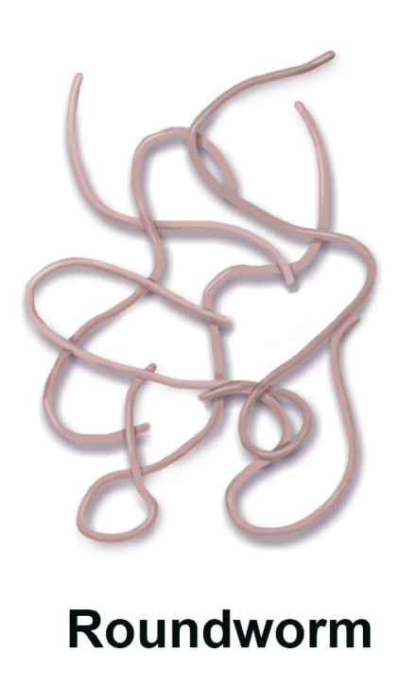

* They are found in the crop, gizzard and oesophagus

**Effect**

* Drop in egg production.
* Weight loss

**Control**

* Remove the laid eggs to avoid other birds picking the worm.

1. **Hookworm**

* They attach themselves to the chicken’s intestinal wall and suck blood.
* They also are found in the gizzard and oesophagus.

1. **Tapeworm**

* Tapeworms affect chicken and other livestock such as cattle, sheep, goats and pigs.

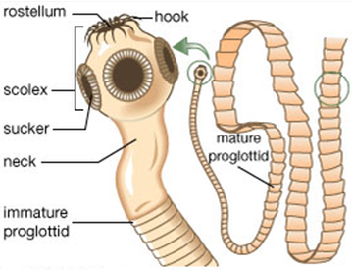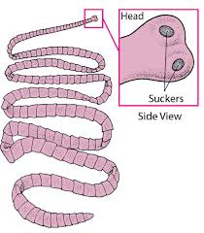

**Effects**

* Heavy infestation reduces the chicken body immunity.

**Control**

* Free range birds should not be allowed to interact with chickens at battery cage or fold pen system.

**PREDATORS OF CHICKEN AND HOW TO PROTECT THE BIRDS**

The common Chicken predators in Malawi include

1. Wild cats
2. Hawks
3. Ravens
4. Alligators
5. Eagles

**Control measures of predators in Chickens**

1. **Fencing**

The right fence will keep predators out and chicken in.

1. **Roofing**

* Installing roof of wire mesh will protect the birds to foil flying predators
* Scaring off the predators by hanging CGs on the wires which have been criss-crossed over the top of the house of poultry.